Save on cost
per sqm.
when you book before
October 31st 99!

CONVERGE ON LONDON

E X H I B I T IO N I N V I T A T I O N

FOR

ICML
8TH International Congress
on Medical Librarianship

July 2-4, 2000

Queen Elizabeth II Conference Centre
Westminster
London SW1
United Kingdom

Brought to you by: The Library Association
www.icml.org

EXHIBITION PACKAGE AND BENEFITS

Prices

All prices listed below are exclusive of Value Added Tax and are quoted per square metre in GB Pounds Sterling. Tax will be added at a rate of 17.5%.

Discounts

Book before October 31st 1999 to take advantage of our special discounts!

Before tax Tax to be added Final Total
- Inline Booth £215 £37.62 £252.62
- Corner Stand £236.5 £41.38 £277.88
- Peninsular Stand £247.25 £43.26 £290.51

After October 31st 1999 the prices will increase as follows:

- Inline Booth £240 £42 £282
- Corner Stand £264 £46.20 £310.20
- Peninsular Stand £276 £48.30 £324.30

What is included

- Shell scheme
- Early evening opening reception
- Daily cleaning of the exhibitor hall aisles
- Round the clock security from set-up to close of exhibition
- Experienced modular stand contractor service
- Professional organisation, marketing and promotion of the event

Attractions

- Large volume of international medical librarians expected to attend - up to 1,000 from overseas and 500 from the UK
- Choose from up to 70 exhibition stands from which to book your space
- High profile representation of visitors from the extensive and buoyant health information sector including a high proportion of senior and middle level managers
- Conveniently located coffee points and catering areas offering the chance to network
- Opportunities for delegate pack literature distribution
- Conference sessions expected to draw target audience and special interest groups

If you serve the library and information industry you cannot afford to miss this exhibition! Promote your services and products to customers who will be looking for the latest information in the following fields:

Electronic Publishing Specialist Furniture Online Systems
Audio Visual Equipment Storage & Shelving Equipment Photocopiers
CD ROM Cataloguing Archive Applications Database Services
Specialist Publishers Library Management Software Security Systems
Subscription Services Health Information Products Laser Printers

LOCATION AND VENUE

About ICML

Every five years, the world’s medical librarians gather to take part in the International Congress on Medical Librarianship, held under the auspices of the Biological and Medical Sciences Libraries Section of IFLA. London’s Queen Elizabeth II Conference Centre will be hosting the 8th Congress on July 2-5, 2000 in what promises to be an event fit to grace the millennium. The theme of ICML is Convergence and the Congress, for the first time ever, will incorporate five other international conferences concerned with health, medical and veterinary information. Set to coincide with this programme is ICML, The Exhibition on July 2-4, 2000.

Why London?

- Excellent communications with a choice of five airports and Eurostar rail links
- Fast journey times within the capital by bus, taxi or underground
- Endless hotels and restaurants to suit all budgets
- Beautiful buildings and cultural heritage by day
- Theatres, shows, pubs and clubs by night

Why the Queen Elizabeth II Conference Centre?

- Convenient location in the heart of Westminster opposite the famous Abbey and within sight of the Houses of Parliament
- High ceilings and spacious surroundings of the Whittle and Fleming rooms where the exhibition will take place
- Fine views of Westminster from the Benjamin Britten Lounge making it ideal for hospitality and networking

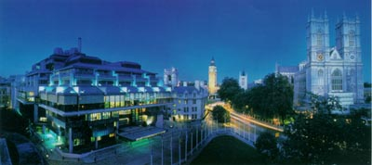

EXHIBITION HOURS AND LOCATION MAP

Build Up Times

Saturday 1 July 17:00 - 22:00

Sunday 2 July 06:00 - 17:30

Exhibition Hours

Sunday 1 July 18:00 Exhibition opens
18:00 - 19:00 Welcome Reception

Monday 2 July 09:00 - 17:15

Tuesday 3 July 09:00 - 17:15
17:15 Exhibition Closure

Breakdown

Tuesday 3 July 17:15 - 21:00
Wednesday 4 July 09:00 - 12:00 (Noon) 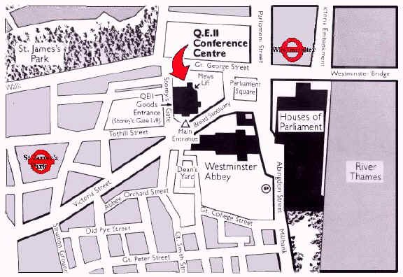

FURTHER FEATURES & OPPORTUNITIES

World Wide Promotion

- This particular conference is only held every 5 years, so participants from all over the world will be especially eager to attend
- Special efforts have been made to market and promote ICML
- A web site unique to the event has been set up where all the latest information can be found
- The Committee has undertaken careful planning over the past 4 years to ensure that ICML will be a success and exhibitors will be satisfied with the end results
- Speakers of international repute are expected to bring 1,500 buyers together to the exhibition from every continent!

Sponsorship

With such a unique conference and exhibition taking place, why not take up the opportunity to promote your company and its product by sponsoring one of the following:

- Welcome Pack Bags
- Pens/Notebooks
- Carrier Bags
- Ticket and Badge Printing
- Direction Signs
- Fun items e.g. baseball hats, balloons etc.
- Sponsor one of our social events - our main one will be a sight-seeing river trip by boat along the River Thames to the millennium Dome with wining, dining and dancing en-route!
- Themed walks or a fireworks display
- Sponsored lunches and coffee breaks in the catering lounge or at one of the coffee points

These are just a few ideas but any number of opportunities are available to help promote your company into the twenty first century! The Library Association is pleased to announce that sponsorship has already been provided for ICML by the following organisations:

For more information about the exhibition please contact:

Emma Beasant - ICML 2000 Exhibition
The Library Association
7 Ridgmount Street
London WC1E 7AE
Tel: +44 (0) 20 7255 0544 Fax: +44 (0) 20 7255 0541
E-mail: emma.beasant@la-hq.org.uk

