“New tricks for old dogs "
Providing an electronic Acute Current Awareness Service for clinical staff within the hospital setting within the UK
Janet Harrison, Department of Information Science, Loughborough University, UK*
Samuel Nikoi, Department of Information Science, Loughborough University, UK
Wendy Stanton, Greenfield Medical Library, Queen’s Medical Centre, University of Nottingham, UK

UK
Nicola Darlington, Greenfield Medical Library, Queen’s Medical Centre, University of Nottingham UK

* corresponding author,J.Harrison@lboro.ac.uk

Introduction
For some 15years there has been a powerful drive in the UK to encourage clinical staff of the NHS to improve the delivering of clinical care by using information effectively. The Patients Charter ,1992, can perhaps be seen at the vanguard of this movement as it enshrined the idea of providing information for patients. This has subsequently developed into the formal framework of Clinical Governance used in the NHS for providing assurances of the quality of care that patient can expect to receive in the clinical environment. The major driver for the implementation of Clinical Governance is to be found in the New NHS Modern and Dependable,which set standards and monitoring systems to guide clinical judgement and also for the assessment of clinical care. Two important pillars and essential elements of Clinical Governance are Evidence Based Medicine and Continuing Professional Development (CPD). The aim of evidence based medicine is to ensure that the current state of knowledge and the best standard of evidence is used by clinical staff used in the treatment of clinical conditions. This stems from the original work by David Sackett. CPD is designed to affirm professional competence through life-long learning activities, updating existing knowledge and skills. These two requirements of Clinical Governance have enormous implications for the provision and use of high quality clinical information within the NHS.

Library and Information Services within the NHS
The NHS is administratively divided into regions, Trent is the administrative region of the focus of this study .Within the regions other subdivisions of administration exist. In the primary sector general practitioner services are brought together to constitute Primary Care Trusts. Provision of services in the secondary sector are provided by Hospital Trusts. Clinical information is routinely provided to clinical staff via the NHS or academic library services. In the secondary sector the norm is for a library to be operating from the same site as the hospital. There are approximately 400 service points in the NHS in the UK. The library may be an integral part of the NHS or an academic library which is aligned to the local university. In the primary sector General Practitioners may have access to a hospital library or clinical library services, depending upon local provision and service level agreements. The provision of information and library services to clinical staff is varied and variable throughout the NHS. The pressure to develop improved and focussed clinical information services within the NHS has resulted in the development of Clinical Librarian services.

The role of Clinical Librarianship in the NHS
It was during the 1970’s that the first attempt was made to introduce the concept of CL in the UK at Guys Hospital in London .Since then the development of the CL in the UK in the NHS has been a slow and rather chequered process. Clinical Librarianship (CL) has today established itself as the main form of service concerned with the provision of medically focused, highly case specific information to clinicians. However, the role of the CL is not routinely found in the many NHS libraries. However, good example of practice exist throughout the UK, one of these is the service provide by the University of Leicester Hospitals (UHL), whom operate across three hospital sites meeting clinicians information needs. Work currently being undertaken by the Librarians at UHL indicates that there are approximately 20 plus CL’s working in the NHS in 2005.
The contribution made by CL to Clinical Governance is a main justification for employing a CL; four major activities stand out which directly support the Clinical Governance programmes, these are:
- Searching for evidence and clinical guidelines in support of the work of groups involved in the development and implementation policies, protocols, and service recommendations;
- Organising training and hands-on workshops aimed at developing the knowledge and searching skills of physicians in the use of digitised information systems and other health-related information resources or database;
- Provision of current awareness services targeting specifically clinicians to help them keep up-to-date with developments in the respective fields. This service can include content page services, alerts of updates on key NHS government websites and also selective dissemination of information services;
- Online enquiry services which provide answers to specific question related treatment, diagnosis and prognosis of various conditions through telephone fax and also email.
To gain knowledge of the information needs of clinicians, various strategies have been employed by clinical librarians. Depending on the setting, CLs, have been assigned to specific medical teams, have being involved in ward rounds, referral meetings, outpatients clinics, team meetings, and educational meetings as evidenced by Reid and Ikkos. The aim is to provide them with the opportunity for developing first hand understanding of information requirements of physicians.

These positive developments have not gone without challenges some of which have been highlighted by Roderick and Roderick. Sargeant and Harrison have also pointed out obstacles, such as differences in the perception of the responsibilities of CLs from other members of staff which prevent them from being considered as an integral part of the clinical team. The evidence of these challenges would suggest that a lot still remains in to be achieved in terms of a cultural shift within the NHS if Clinical Librarians are to gain recognition and acceptance.

Focus and Background of the Project
Electronic clinical information provision in the Greenfield Library at the University of Nottingham is the focus of this project .The Greenfield Library at Nottingham does not have a Clinical Librarian in situ, possibly the missing link in the chain to the provision of Clinical information. It can however, boast a Medical Librarian and several clinical subject specialists i.e. Nursing and Medical who provide the clinical information focus for clinical staff. The library is fully engaged in the provision of first class information for clinical staff.

Prior to the beginning of this project the Medical Librarian at the Greenfield Library was aware of a variety of NHS Libraries, regional initiatives that had been introduced by various libraries and health knowledge managers to provide access to health information resources and to also promote knowledge sharing amongst staff. For example within the Trent Work Force, (personnel working within the designated administrative NHS region of Trent) primary care librarians and knowledge managers from across Trent and South Yorkshire have been sharing information and resources to produce monthly information bulletin on management issues such as “ The Trent Information Bulletin” and related “Daily Health News” since 2001 with regular feedback received from customers.

Against this background and coupled with her serious concerns the Greenfield Medical Librarian recognised that whilst current awareness services existed for Primary Care staff within the Trent region an equivalent service was not in place to support the clinical information needs of other staff groups working in the secondary sector i.e. the acute NHS trusts within the Trent region. The project formulation grew from these observations. Funding was subsequently sought and successfully obtained from the Trent Workforce Development Confederation. The aim of the project was to develop and provide a current awareness service for acute clinical staff within the Trent region.

Acute Service Current Awareness Service (ASCAS)
The Acute Service Current Awareness Service (ASCAS),is a multi-disciplinary information service, it is a web-based information service and it was developed by the Greenfield Medical Library, Nottingham and is jointly managed by the Department of Information Science, Loughborough University.

The Greenfield Medical Library provides a range of library and information services to employees of University Hospital NHS Trust, Queen's Medical Centre, Nottingham City Hospital NHS Trust and Nottinghamshire Healthcare NHS Trusts. The project started in August 2004 and was launched in November during the UK National Health Libraries Week .Following several consultations with clinicians in four acute trusts in the region to agree on the format and content of the service, the main aim and objectives of the service emerged as:

Aim: To improve and enhance access to high quality resources for academic and NHS staff and students;

Objectives:
- To facilitate access, independent of the location of the users 24/7;
- To provide value for money and avoid the need for duplication by other library/NHS staff groups;
- To improve cross-institutional collaboration between the NHS and HE;
- To complement services provided in other subject disciplines;
- To enhance the role of information professionals in supporting the NHS workforce;
- To identify relevant content in consultation with health professionals working within the confederation;
- To promote the service via several websites including Nottingham University, Trent Electronic Library for Health and BIOME.
The ASCAS service monitors over one hundred and fifty key websites highlighting new report and guidelines relevant to the clinical information needs of NHS staff. This data is analysed and formatted appropriately by the medical librarians and subsequently delivered to the desk top of staff. There are nine searchable categories. Four of these focus on general interests:
  - Health news;
  - New Reports and Guidelines; published by agencies such as the Department of Health;
  - Research reports; from journals and scientific meetings including sources of funding for research and development;
  - Continuing Professional Development, (CPD) essential for appraisal and revalidation.
The other categories are focussed on the clinical and nursing issues:
- Medicine;
- Surgery;
- Women and Children;
- Nursing ;
- Diagnostics and Allied Health.
The service is hosted on the website of Nottingham University and can be accessed via a link. The service has been advertised via a banner on the Trust website, and also through presentation, flyers and personal contacts.

Evaluation of ASCAS
Six months after the service was launched, this evaluation was carried out to gain feedback about the service from staff members.

Study Objectives
The specific objectives of the evaluation exercise were as follows:
- To determine the users of the service;
- To establish the subject headings most popularly used;
- To determine the motivation for the use of the service;
- To assess the relevance and level of satisfaction of the service;
- To gain some insight about reasons for non-use of the service;
- To determine areas of possible future improvement.;

The evaluation started in July 2005, and is still ongoing. This article reports the preliminary findings emerging from the evaluation exercise.

Research Methodology
The number of potential users of the ASCAS service within the Trent workforce, i.e.: (those personnel working within the designated administrative region of Trent in the NHS) dictated that a quantitative method was deemed most appropriate to capture the most data from a comprehensive range of users and non users. The data collection tool used was a questionnaire to be delivered electronically. The second reason for the use of the survey method was the benefit it would provide for analysis of data which could be extrapolated to the wider target population within the Trent work force. The use of the questionnaire as a method of data collection is consistent with other evaluation exercises on health information provision within the NHS evident from work carried out by Nicholas, Huntington and Williams Ebenezer Webster & Williams.

Sample population
The sample population for this evaluative study was the Trent workforce. This is a potentially huge numbers running into some thousands of staff .This total population was deemed by the research team to be outside the scope and remit of the proposed study. Therefore, the research team decided to concentrate on sampling those members of staff working within one of the largest NHS Trusts in the region; the Queen’s Medical Centre, Nottingham (QMC). Principally because it is situated on the same site as the Greenfield Medical Library, it was thought that it would be known to staff as a major clinical information provider.

Sample size
The research team decided to use Consultants and Senior Nursing staff working at the QMC as the sampling frame for the evaluation exercise. The Chief Executive of the QMC was contacted and permission sought and gained to administer the questionnaire to clinical and nursing staff. The total sample size was 440 clinical and nursing staff; including Ward Managers, Head Nurses and Matrons and Consultants.
.

Sample method
The main sampling strategy proposed was to obtain a Random sample . However, as is outlined in the description of the questionnaire distribution a Convenient sampling method was employed.

Questionnaire distribution
Difficulties were experienced in obtaining a comprehensive list of clinical and nursing staff from the NHS organisation, constituting the sample set. Therefore, two different approaches for questionnaire distribution were used to elicit response from users and non users.

The protocols existing within the NHS regarding contacting individual members of staff initially influenced the research team to use a third party ,the P.A of the Chief Executive at Q.M.C to circulate an email to the sample set informing them of the evaluation exercise. Via the email staff were asked to go to a free website my3q rform.com hosting the questionnaire to complete and submit it online.The initial email also asked that the evaluation request was cascaded down to other members of staff within the organisation.

Secondly the research team used a direct approach to engage respondents. A list of personnel showing initial interest in a current awareness service had been provided by the Greenfield Medical Librarians team to the research team. Personnel on this list were all emailed individually to ask them to complete the questionnaire. This second mailing was undertaken a month after the first.

Questionnaire Design
The questionnaire had six major sections and was designed to target both users and non-users of the service. The first part of the questionnaire was focussed on gathering background information of respondents. This was to assist in building a profile of the users in order to draw comparison between different types of user. The second part of the questionnaire covered subject interest aimed at assessing the subject areas which were most popular to respondents. Section three was designed to understand issues connected to motivation for use of the service. Section four focused on questions of user satisfaction. The fifth and six sections requested suggestions about possible areas of improvement and non use respectively.

Interim Study Results

Background of respondents
The results show that respondents come from a fairly mixed specialist background including some senior officers. The job titles provided includes Consultant Neurologist, Head Occupational Therapist , Consultant Surgeon , Head of Continuing Professional Development , Sister , and Consultant Physician. The actual specialities listed includes, Neurology, Medicine , General Surgery , Professional Education , Ophthalmology , Respiratory Medicine , Healthcare Professions Education. Incidentally the specialist background of respondents is also identical to the subject headings used for the service.

Subject interest
When asked to specify their subject area of interest, the analysis of respondents preferences revealed interest in both broad and specialised subject areas. The broad subject areas listed were again similar to the subject headings of ASCAS. They include Integrated Medicine, Current issues in healthcare, Professional Development, Paediatric services and Nursing. The greater majority of respondents were however interested in more granulated subject areas. For example one respondent, a Neurologist, reported his specific subject interest as movement disorder, cognition and neuro-degeneration. Another respondent, Surgeon gave his area of interest as, Transplantation, Day Surgery, Endocrine Surgery. Other specialised subject areas which emerge from the analysis include, cardiac rehabilitation, head injury, sepsis , lung cancer, and chronic obstructive pulmonary disease (COPD). The evidence from the analysis of subject interest suggests that most of the respondents are interested in general as well as specific health topics.

Service Usage.
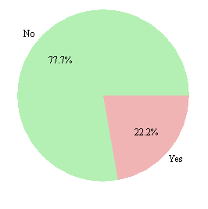
Of the total number of respondent, it emerged that a high proportion have never used ASCAS for the eight months it has been running. The percentage distribution of usage is as follows.

Use of ASCAS

Fig.1

Of the 22.2% who indicated that they use ASCAS, half (50%) reported that they use the service on a weekly basis whilst the other half said they only visit the ASCAS site on a monthly basis. The popular subject areas which were browsed included news items, new reports and guidelines, continuing professional development, nursing, and diagnostic and allied health.
Three motivations emerged for using the service. They are: personal development; teaching and keeping up to date. No indication was given for use of ASCAS for clinical decision making.

Of the large proportion (77.7%) who have never used ASCAS, reasons for non-use are follows:

Non Use of ASCAS
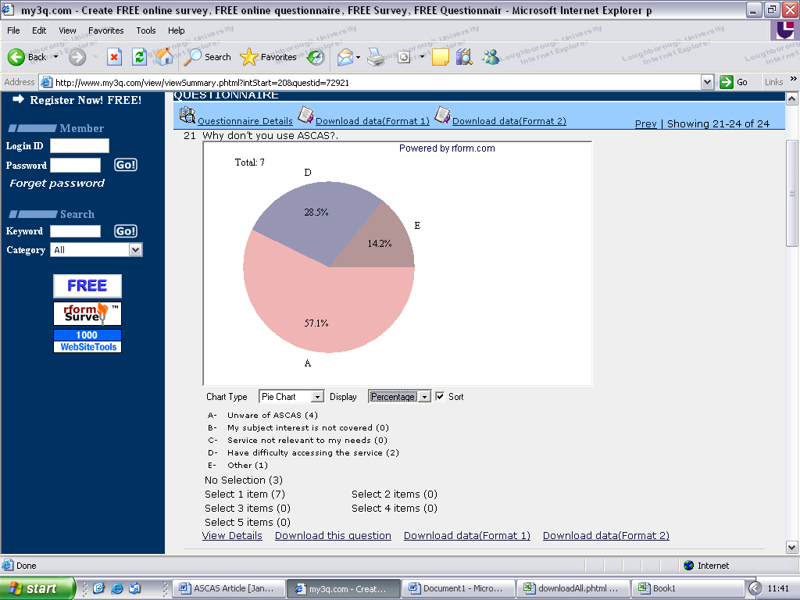
Problem accessing service
Unaware of
No reason

Fig .2
As shown in Fig 2 close to 60% are unaware of the service whilst about another third have problems accessing the service. No reasons were assigned by the rest of the respondents for not using the service.

In answer to “How do you keep up-to-date?” non-users of ASCAS reported the following:

Non users methods for keeping up- to -date

Own Journal
25 %
18 %
18 %
12 %
12 %
9 %
6 %
Consult colleagues
Seminar Workshop Conference
Subscription to alerting service
Monitoring websites
Academic and NHS library
Email distribution list

Fig.3

Judging from the fact that the majority of the respondents were senior members of staff, it is not surprising that they subscribe to journals in their own field.

Service Satisfaction
Of the proportion of respondents who use the service, the greater majority reported that they were quite happy and satisfied with the service. The reason for satisfaction was reported to include the following: coverage of subject area of interest; relevance of information provided and up-to-date of information. Others indicated that they found the abstract quite informative and also that the service was very easily accessible to them. All the users of ASCAS were unanimous that the service was excellent and that they are more likely to recommend it to others.

Areas of possible improvement
Both users and non-users of the service suggested that the service should be advertised more widely and also that email alerts should be set up. The non users however added that the subject area of ASCAS should be expanded and also that the service should be made more accessible.

Interim Observations
The initial method of questionnaire delivery may not have been the most optimum to use. It is recognised that in using a third party another level of bureaucracy and complexity is added for the respondents. However, the research team was influenced in their choice of data collection instrument to be a questionnaire delivered electronically for several reasons. First, the level of access statistics for ASCAS within the initial months of the launch of the service indicated that a sufficient number of clinical and nursing staff was accessing the service to provide an acceptable level of response for evaluative purposes. Secondly, the research team were informed that many of the clinical and nursing staff had access to email and p.c. Thirdly, previous research had shown this to be a successful method in capturing an adequate response rate.

The early results display a relatively low response rate this can be attributed to several factors:

- In reality acute NHS hospital staff do not all have individual access to a p.c or email;
- Some email addresses were incorrect causing the message to bounce back;
- The email from the P.A of the Chief Executive of QMC would have had carried a limited authority but it may have been lost amongst many more important or relevant hundreds in an inbox. One Deputy Director of Information Services in a Hospital Trust anecdotally reported that he received 250 emails per day;
- Some respondents had difficulty in accessing the free website
my3qr rform.com,hosting the questionnaire.

Key factors can be considered as:

- The ASCAS service had not been sufficiently promoted to encourage use by the clinical and nursing staff prior to commencing the evaluation exercise;
- The ASCAS service does not have a clinical champion ,this is essential if the service is to gain credence and use amongst clinical and nursing staff, as detailed by Harrison and Sargeant in 2002.

All the users are enthusiastic about the service and think it excellent, however, it is too early in the study to assess if the initial project aims have been successfully met. Evaluation continues… it would seem that “old dogs cannot learn new tricks”, just yet.

References

The Department of Health. The Patients Charter,London:HMSO;1991
The Department of Health. The New NHS Modern and Dependable,CM3807.London:The Stationery Office;1997
Sackett D. et al. Evidence Based Medicine: a new journal to help doctors identify the information they need. British Medical J. 1995; 310 (29): 1085-1086.
LISU, Library and information Statistics Unit. Library and information Statistics Table 2002. Loughborough , (UK): LISU Loughborough University 2002.
Reid L, Ikkos G, Hopkins W. Clinical Librarians at Barnet Primary Care Trust; addressing the information requirements of clinical governance. Health and Information Libraries J. 2002; 19 (1) pp. 52 – 55
Roderick N, Roderick A. The myth of accurate clinical information. In: Lugon M, & Secker - Walker J, editors. Advancing Clinical governance. London: Royal Society of Medicine Press Ltd; 2001. p 111-24.
Sargeant S JE, Harrison J, Clinical Librarianship in the UK: temporary trend or permanent profession? Part 1: a review of the role of the clinical librarian. Health and Information Libraries J. 2004; 21 (3) : 173 – 181.
Gardner H, Brunt D, Sherratt A, Clifford A. Knowledge is power – the Trent Primary Care Current Awareness Service. In He@lth Information on the Internet August 2004. p 7 -8.
Nicholas D, Huntington P, Williams P. An evaluation of the use of the NHS touch-screen health kiosk: a national study. ASLIB Proceedings. 2002; 54 (6): 372 -384
Ebenezer C, Usability evaluation of an NHS library website. Health and Information Libraries J. 2003; (3): 134 – 142.
Webster, R. & Williams P. An evaluation of the NHS Direct online health information email enquiry service. ASLIB Proceedings 2005; 25. (1) 48 – 62.
Harrison J, Sargeant S JE, Clinical Librarianship in the UK: temporary trend or permanent profession? Part 2. present challenges and future opportunities. Health and Information Libraries J. 2004; 21 (4): 220 – 226.

