TITLE : Azalea:- an Italian database for oncology patients

AUTHORS: I. Truccolo1, G. Cognetti2, W. Russell-Edu3, A. Bogliolo4, A. Codonesu5, R. Ricci1 P. Seroppi1 A. Trocino6 R.Truffelli4 A.Florita5 G. Bocchini4 , R. Bufalino5 L.Cecere2 M. Montella6, F. Cognetti2 P. De Cillis7 K. Bianchet1

AFFILIATIONS: 1 National Cancer Institute, Oncology Referral Centre, Aviano, Italy, 2 Regina Elena Cancer Institute, Rome, Italy, 3 European Institute of Oncology, Milan, Italy, 4 National Cancer Research Institute (IST), Genoa, Italy , 5 National Cancer Institute, Milan, Italy , 6 National Cancer Institute, Naples, Italy, 7 National Cancer Institute, Bari, Italy

CORRESPONDENCE:

Ivana Truccolo
Centro di Riferimento Oncologico Aviano IRCCS
Via. Pedemontana Occ.,12 –
30081 Aviano (PN)

ITALY
Tel +39 0434 659248; FAX +39 0434 659358; E-mail: itruccolo@cro.it
www.cro.it; www.azaleaweb.it;

DECS Key words: patient education, internet, information services, information dissemination, physician-patient relations, neoplasms, user-computer interface, Italy
BACKGROUND

The quality of communication between doctor and patient is the key to a successful outcome in the consultation. This is particularly so in cancer, which is still shrouded in fear, anxiety and taboo. (1-16).

The Internet has become an increasingly common source of medical information for patients with cancer.

In Italy, there are approximately 20 million Internet users among those over 18-years old – 42% of the majority age population. This figure comes from CENSIS and was presented in July 2005 as part of a survey entitled “The web as a worldwide health consultant”. This same survey revealed that 26% of the information searched for concerns health, i.e. 5 million Italians conduct health-related Web searches.

In the 1980s cancer sufferers, there was only one source for authoritative information, namely PDQ – Physician Data Query, from the National Cancer Institute in the US. There are today, several authoritative sources, MedlinePlus (USA, 1998), CancerBacup (UK, 1995), AiMaC (the Italian Association for Cancer Patients), with an Italian translation of PDQ (1997); CISMeF-patients (Catalogue and Index of French-speaking Medical Sites. France 1997) and now – AzaleaWeb (Italy, 2003)

In Italy as a consequence of the growing use of the Internet, we have witnessed a profusion of information in the Italian language targeted towards the ever-increasing demands of patients. However in the field of information, quantity without validation, management, organisation and specific know-how will lead to patients being poorly served. This has provided added impetus to create an Italian database of literature for patients and the public, where Italian-language information aimed specifically at cancer patients is collected, organised and validated. Patients are thereby enabled to obtain detailed, up to date and straightforward answers to their questions (17).

In 1997/8 the CRO of Aviano started to build the first nucleus of its database, comprising some 700 records related to information materials about cancer and about 350 records related to their authors: mostly patients associations and no-profit organizations.
In 2003 the project was extended nationwide when the ACC (Alleanza Contro il Cancro, “Alliance Against Cancer”), a body set up by the Ministry of Health, recognised its national importance: the project was therefore expanded to include the collaboration of the seven oncology IRCCS (Scientific Institutes for Research, Hospitalization and Health Care) comprising the ACC thus becoming a multicentric project financed by the Ministry through ACC. Its name, Azalea, was chosen as azaleas are the plants distributed in Italian piazzas by the Italian Association for Cancer Research (AIRC) when collecting research funds.

THE OBJECTIVES OF AZALEA
Azalea aims to offer the non specialist consumer ready access to validated information and enable users to gain as much knowledge as they need about a particular cancer condition, confident in the knowledge that the service offered is up to date.
Azalea also aims to enrich the work of those providing materials aimed at cancer patients and the general public, to stimulate the production of other materials regarding research discoveries and to increase the visibility of voluntary and non-voluntary medical and scientific bodies.
To do this it collects, evaluates and catalogues material in accordance with the international bibliographic standards of description and indexing of documents.
The different information sources, written in Italian or translated from English include: books, journals, book chapters, articles, leaflets, compact discs, cassettes, and web sites.
Although some of this material is simply referenced and described, some of it is downloadable in its entirety. As of July 2005 Azalea contains 3001 records related to all kind of materials, 580 of them are full text, 83 records are completed with the “quality control process”,212 evaluated web sites,1381 Associations and organizations’ records.
Azalea, in terms of form and content, draws on a body of international experience, such as
- CancerBacup (http://www.cancerbacup.org.uk/) (18)
- Cancer.gov (http://www.cancer.gov/cancer_information/pdq/) (19)
- Medlineplus (http://www.nlm.nih.gov/medlineplus/medlineplus.html) (20)
- Caphis (http://caphis.mlanet.org/)
- CISMeF (www.cismef.rouen.fr) (20)
- Quality Internet resources (http://biome.ac.uk/biome.html) (21)

The work of Azalea involves librarians, information scientists, informatics experts, psychologists, doctors and nurses, in collaboration with the voluntary associations and medical and scientific organisations who have made their materials available.

Taking our lead from the work of the University of Toronto’s Gunther Eysenbach (22-24), we formed a Materials Evaluation Committee for the initial stage of the project, which was entrusted with the task of assessing every document entered into the database. This was done by means of evaluation grids drawn up from a study of similar grids described in the international literature (25-28).
The documents to be evaluated are submitted to:
- a mixed group consisting of psychologists, but also with librarians and experts in the humanities, who will evaluate the communicative style;
- a mixed group of doctors of various specialties, biologists, pharmacologists etc. who will analyse the content.
Three grids are used for the evaluation, one for each of the three aspects, drawn up on the basis of the international literature on information resource evaluation; each grid consist of several criteria to use for document evaluation:

TECHNICAL-FORMAL ASPECTS (to be completed by the librarian)
Transparency
Appropriateness
Authority
Currency and date
Interactivity
Accessibility and usability
Standards and conduct criteria

COMMUNICATIVE STYLE (to be completed by the psychology-humanities staff)
Comprehensibility of information
Relativity of information
Emotional impact of the information

CONTENT (to be completed by the psychology-oncology staff)
Validity
Precautions
Usefulness

The evaluator (or group of evaluators) is requested to assign a score (the model proposed involves an evaluation in accordance with the Discern model with a scale of 1 to 5 as in the Likert scale) for each criterion and to write a brief summary (no more than three lines) in which the strong and any weak points of the documented are highlighted. The evaluator is also required to indicate whether the document under examination is considered appropriate for “first level” information, that is, aimed at the general public, who have not explicitly requested the information – or “second level” information, i.e. aimed at a more expert public.
The professional librarian of Azalea Team writes up the final summary.

The Azalea database is designed so as to facilitate information retrieval by those with little or no expertise. It is in fact possible to conduct a search by inputting commonly-used terms. However it is more effective to search by means of keywords which have already been assigned to each record. Such keywords provide an in-depth description of the subjects dealt with in the database. Those who come to search the database are presented with a choice of descriptive terms from a readily-accessible list so they may pinpoint their topic of interest.

The keywords, assigned by professional cataloguers from the project team are drawn from the Italian version of the Medical Subject Headings (MeSH), the thesaurus created to index the Medline database, and translated by the Documentation Service of the Superior Institute of Health (Istituto Superiore di Sanità ), Rome.

In July 2003 the database became available via “e-oncology”, the ACC portal (http://www.e-oncology.it): the first experimental version of Azalea on Web. However a completely new revised software was designed by a team of technicians of the CRO of Aviano and the Consortium of Bioengineering and Medical Informatics of the University of Pavia (CBIM) . One of the main features is that the input of new data into the archive of this new software can take place in a shared mode over the Internet by authorised expert partners of the Project Team. So information in process will be accessible to users through Azalea in real time, before the citations are validated by Multicentric Validation Team. Two levels of authority are additionally be maintained, to ensure the adherence to the cataloguing standards of the records input by the different libraries.

The first version of this software, scheduled for early 2004, was launched on April 5 at Cernobbio Heath Forum, - an important Italian exhibition and on April 28, “Azalea Day”, an Azalea Team meeting was held to teach partners how to work together using the new software (http://www.azaleaweb.it).

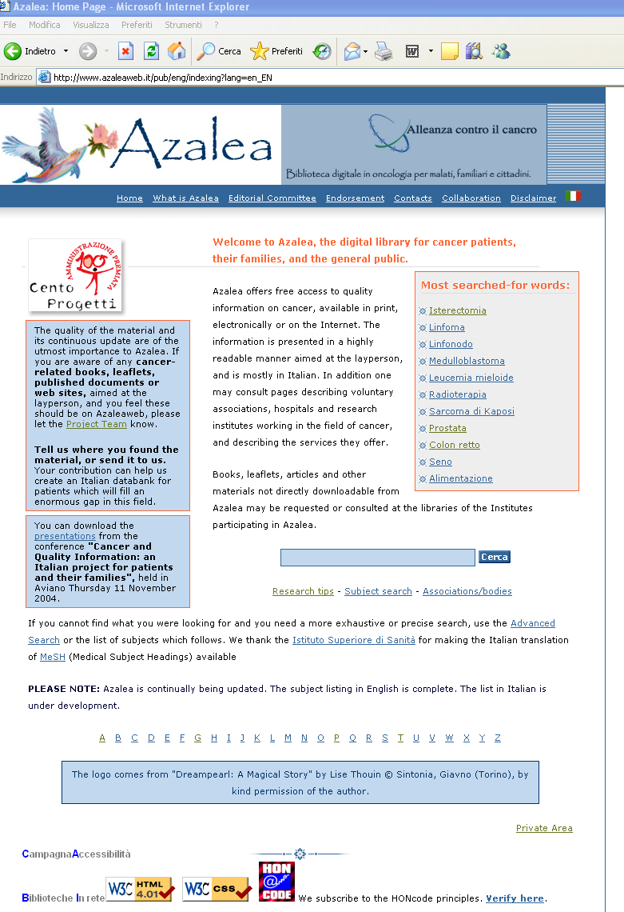

The system enables easy access to reviewed documents: if they are unavailable in full text, the user is told how they can be obtained, whether directly from the document producers (authors or associations), or from the libraries participating in the project which have set up purpose-built document supply services. In this way those who produce cancer information for patients, such as associations in the field of oncology, medical and scientific organisations, hospitals, can become better known to the public, and easily contactable, irrespective of their Web presence or absence, and regardless of their physical location. A “Database of Associations” is conveniently integrated into the principal database.
The statistical reports detailing the initial number of accesses to the database between May and August 2004 have been studied. They show a constant increase in the number of visitors as can be seen the graph in Figure 1a. In Figure 1b, a progressive increase in access at the weekend, a period that one would hypothesise as predominantly comprising
access by patients and families rather than specialists in the field.

Fig 1a Fig 1b

Figure 2 shows the phrases and words most often searched and these embrace a wide range of topics: searches for symptoms that may suggest cancer, patient care, and specific topics such as sentinel lymph nodes, and single organ cancers such as those of the stomach, lungs, bone, blood and thyroid.
The analysis conducted so far is only partial; an investigation over a prolonged period could perhaps reveal further characteristics of the usage and most-requested subjects and thereby enable the product to develop even more closely to meet users’ needs.

Fig. 2

CONCLUSIONS
It is a well-known fact that the amount of information with which we are bombarded never ceases, and the all-pervasiveness of the Internet adds to the confusion inherent in the information explosion.
The general public and patients need information of quality so that they can “get better at asking questions and understanding the answers”. Healthcare workers require that the material on offer to the public be intelligently and critically evaluated and that the public be encouraged to use it well. At the end of the day, it is a matter of ensuring that informed consent is well and truly “informed”. If the information with which the patient and doctor work is of consistently high quality the benefits to the doctor patient relationship and indeed to medicine in general, are obvious.

The organisation and the visibility or retrievability of the resources enables each centre to rationalise its services, avoiding duplication or omissions in the holdings of materials for the “non-scientific community” and a uniform classification and indexing of such material.

Collaboration between the various partners is fundamental to ensure updating, improvement and development of Project Azalea both from a qualitative and a quantitative point of view.

Italy is on the threshold of being able to make an original contribution to the sector of quality information for its patients. Azalea hopes to fill the information gap that exists between Italy and other European countries and the USA with the creation and continuous update of the first multicentric digital cancer library in the Italian language.

References

- Stone, M. What Patients Want From Their Doctors. BMJ 2003;326(7402):1294.
- Ehrenberger, H. E. Cancer Clinical Trial Patients in the Information Age: a Pilot Study. Cancer Pract. 2001;9(4):191-7.
- Friedrichsen, M. J., Strang, P. M., and Carlsson, M. E. Cancer Patients' Perceptions of Their Participation and Own Resources After Receiving Information About Discontinuation of Active Tumour Treatment. Acta Oncol 2000;39(8):919-25.
- Wallberg, B., Michelson, H., Nystedt, M., Bolund, C., Degner, L. F., and Wilking, N. Information Needs and Preferences for Participation in Treatment Decisions Among Swedish Breast Cancer Patients. Acta Oncol 2000;39(4):467-76.
- Fleissig, A. Information Needs of Patients With Cancer. Patients Are Frightened and Their Information Needs Fluctuate. BMJ 9-9-2000;321(7261):632.
- Lockwood, S. and Manaszewicz, R. Information Needs of Patients With Cancer. Patients' Perspectives May Vary. BMJ 9-9-2000;321(7261):632-3.
- McKenzie, J. Information Needs of Patients With Cancer. Similar Study Had Similar Findings. BMJ 9-9-2000;321(7261):632.
- Keller, M. Information Supplied to Cancer Patients and Their Caregivers--No More Unmet Needs? Support.Care Cancer 2001;9(8):563-4.
- Jefford, M. and Tattersall, M. H. Informing and Involving Cancer Patients in Their Own Care. Lancet Oncol 2002;3(10):629-37.
- Mesters, Ilse, van den Borne, Bart, De Boer, Maarten, and Pruyn, Jean. - Measuring Information Needs Among Cancer Patients. - Patient Education & Counseling 43(3):Jun-264.
- De Lorenzo, F., Ballatori, E., Di Costanzo, F., Giacalone, A., Ruggeri, B., and Tirelli, U. Improving Information to Italian Cancer Patients: Results of a Randomized Study. Annals of Oncology 2004;15(5):721-5.
- Ruggeri, B., Ballatori, E., Casali, P., Tamburini, M., Licitra, L., Mencaglia, E., Roila, F., and Cortesi, E. Awareness of Disease Among Italian Cancer Patients: Is There a Need for Further Improvement in Patient Information? Annals of Oncology 1999;10(9):1095-100.
- Passalacqua, R., Caminiti, C., Todeschini, R., Filiberti, S., Sivelli, C., Pucci, F., Diodati, F., Dalla Chiesa, M., and Campione, F. Prospective, Randomized Trial to Test the Efficacy of a New Modality of Delivering Information and Support to Cancer Patients in the Italian Oncological Divisions. Annals of Oncology 2002;13 (Suppl 3: 4th National Congress of Medical Oncology. Torino, 28 settembre-1 ottobre 2002):1.
- Truccolo, I., Merighi, R., Ciolfi, L, Capello, F., and Carbone, A. An Italian Oncology Data Bank for Patients and Common People. EAHIL Newsletter 2002;2002(61):21.
- Passalacqua, R., Campione, F., Caminiti, C., Salvagni, S., Barilli, A., Bella, M., Barni, S., Barsanti, G., Caffo, O., Carlini, P., Cinquemani, G., Di Costanzo, F., Giustini, L., Labianca, R., Mazzei, A., Olmeo, N., Paccagnella, A., Toscano, L., and Cocconi, G. Patients' Opinions, Feelings, and Attitudes After a Campaign to Promote the Di Bella Therapy. Lancet 17-4-1999;353(9161):1310-4.
- Passalacqua, R., Caminiti, C., Salvagni, S., Barni, S., Beretta, G. D., Carlini, P., Contu, A., Di Costanzo, F., Toscano, L., and Campione, F. Effects of Media Information on Cancer Patients' Opinions, Feelings, Decision-Making Process and Physician-Patient Communication. Cancer 1-3-2004;100(5):1077-84.
- Truccolo, I., Capello, F., Merighi, R., Carbone, A., Ricci, R., Seroppi, P., Steffan, A., and Greatti, E. An Italian Oncologic Data Bank of Materials for Patients and Common People on CD ROM Made by "CRO, Aviano (Italy): Towards a National Italian Project Called Azalea by "Alliance Against Cancer". MIE2003: Medical Informatics Europe.The new navigators: from professionals to patients.St.Malo (FR) 4-7 Mai. Proceedings on CD ROM 2003: 1-6.
- Boudioni, M. An Analysis of First-Time Enquirers to the CancerBACUP Information Service: Variations With Cancer Site, Demographic Status and Geographical Location. Br J Cancer 1997;79(1):138-45.
- Berner, E. S. The Effects of the PDQ Patient Information File (PIF) on Patients' Knowledge, Enrollment, in Clinical Trials, and Satisfaction. J Cancer Education 1997;12:121-5.
- Darmoni, S., Thirion, B., Platel, S., Douyere, M., Mourouga, P., and Leroy, J. P. CISMeF-Patient: a French Counterpart to MEDLINEplus. J Med Libr Assoc 2002;90(2):248-53.
- Sacile, R., Wiley, T., and Lombardo, C. Quality Assurance Guidelines for a Biomedical Information Web System: the Working Experience of the BreakIT Project. Med Inform.Internet.Med 1999;24(2):109-20.
- Eysenbach, G. and Kohler, C. Does the Internet Harm Health? Some Evidence Exist That the Internet Does Harm. BMJ 2002;324(7331):238-9.
- Eysenbach, G., Powell, J., Kuss, O., and Sa, E. R. Empirical Studies Assessing the Quality of Health Information for Consumers on the World Wide Web - A Systematic Review. Jama-Journal of the American Medical Association 2002;287(20):2691-700.
- Eysenbach, G. Websites on Screening for Breast Cancer: "Infodemiology" Studies Have Surely Had Their Day. BMJ 27-3-2004;328(7442):769-70.
- Stromborg, M. F. and Cohen, R. Evaluating Written Papers Education Materials. Semin Oncol Nurs 1991;7(2):125-34.
- Biermann, J. S., Golladay, G. J., Greenfield, M. L., and Baker, L. H. Evaluation of Cancer Information on the Internet. Cancer 1-8-1999;86(3):381-90.
- Davis, S. W., Nealon, E. O., and Stone, J. C. Evaluation of the National Cancer Institute's Clinical Trials Booklet. J Natl.Cancer Inst.Monogr 1993;(14):139-45.
- Gilliam, A. D., Speake, W. J., Scholefield, J. H., and Beckingham, I. J. Finding the Best From the Rest: Evaluation of the Quality of Patient Information on the Internet. Ann R.Coll.Surg.Engl 2003;85(1):44-6.
- Eysenbach, G. and Till, J. E. Ethical Issues in Qualitative Research on Internet Communities. Review. BMJ 2001;323(7321):1103-5.
- Cognetti, G. and Cecere, L. E-Oncology and Health Portals: Instructions and Standards for the Evaluation, Production Organisation and Use. J Exp.Clin.Cancer Res 2003;22(4):677-86.

