AVAILABILITY AND ACCESSIBILITY OF INFORMATION: A CASE OF TRADITIONAL AND ALTERNATIVE MEDICINE (TM AND AM) IN UGANDA

MAIN THEME: Commitment To Equity
SUBTHEME 7: Traditional and Alternative therapies.
By
Alison Annet Kinengyere (BLIS, MSc. INF. Sc)
alisonk@med.mak.ac.ug
Sir Albert Cook Medical Library, Makerere University,
P.o Box 7072, Kampala, Uganda, East Africa.

ABSTRACT
The last decade has witnessed widespread use of TM and AM. This trend has resulted from challenges in application of scientific medicine, with cases of incorrect use and application, which has harmful effects on the consumers. The Government recognizes TM and AM as important complementary service providers. TM/AM is practiced either in isolation or complementary to scientific medicine in prevention, diagnosis and treatment of ailments. Given the growing role of TM/AM, and the scanty information about this subject, a study was done in and around Kampala in 2004. The focus of the study was to identify: information needs and sources for TM/AM beneficiaries and the challenges they face; what types of information have been documented and ways for improvement. Questionnaire, structured interview guide and direct observation were used to collect data. The study concluded among other things, that there is need to establish a database of TM / AM practices to improve services, enhance research in TM / AM and for future reference. Recommendations drawn for TM / AM stakeholders were reported.

Introduction
The discipline of medicine has in the last years undergone considerable changes as more research is done on other practices outside the scientific endeavor (allopathic medicine). This has been in response to the challenges encountered in the provision and application of the mainstream (Western) medicine, such as affordability and accessibility. Practices such as local traditional medicine (TM) and Alternative medicine (AM) have grown and are now used by many to compliment the treatment, cure and prevention of diseases.

However, basic health information as an important ingredient for the attainment and sustainability of TM/AM knowledge and practices is often deficient in society, both for the practitioners and the patients. The beneficiaries of TM/AM endeavors may not have the same exposure to the information and resources enjoyed by beneficiaries of mainstream medicine. This therefore calls for equitable access to health care resources and information about these resources.

This research aims at understanding the information needs and sources of both practitioners and patients. Its output will enable a better understanding of the challenges faced by the TM/AM beneficiaries in their operations, and make recommendations for enhanced health information availability and accessibility to them for an appropriate conception of their performance.

TM refers to all systems of health care other than modern scientific medicine (dictionary.com). TM includes diverse health practices, approaches, knowledge and beliefs incorporating plant, animal and/or mineral-based medicines, spiritual therapies, manual techniques and exercises, applied singularly or in combination to maintain well-being, as well as to treat, diagnose or prevent illness (WHO, 2002). The TM practice is based on the indigenous knowledge of a given group of people and their experiences in context of the local culture and environment.

TM practitioners comprise of herbalists, traditional birth attendants, bone setters, psychic and spiritual healers who use indigenous knowledge to develop materials and procedures. Some countries consider TM as being complementary (used together with conventional medicine), or alternative (used in place of conventional medicine), hence the term Complementary or Alternative Medicine (CAM). CAM is defined as “drugs or therapeutic methods that have not been proven scientifically” (Samano, 2005). The researcher refers to TM to mean Traditional, Complementary and Alternative Medicine.

Background
Uganda has an estimated population of 20 million. 89% of the total population lives in rural areas. It is estimated that over 80% of the Ugandan population relies on TM practice (Bannerman, 2004). The World Health Organization Report (1996) indicates that Uganda’s health status remains poor, with many prevalent diseases, thus need to utilize traditional African knowledge and herbal medicines.

TM practitioners in Uganda operate under an umbrella organization known as the National Traditional Healers and Herbalists Association. TM practitioners are under the jurisdiction of the Ministry of Women in Development, Culture and Youth where as allopathic practitioners are under the Ministry of Health. The Government recognizes traditional health systems and associated networks as important health service providers and is doing joint research with TM practitioners through a Government research institute, the National Chemotherapeutics Research Laboratory (NCRL).

TM is widely practiced in Uganda, sometimes in isolation or, as in the case of many patients, to complement allopathic medicine in the prevention, diagnosis and treatment of a wide range of ailments. A number of factors have led to the growth of TM in the country:
- Accessibility - TM is more accessible than allopathic medicine. The practitioners live and work within the communities and the population has easy access to their services, making them generally accessible.
- Affordability - It is affordable. Most Ugandans cannot afford the high costs of western medicine, despite the cost-sharing measures instituted by the Government.
- The desire to:
  - try an alternative when they feel that main stream medicine has somehow failed them.
  - try something that has been recommended by a friend, or relative as effective.
  - try something more natural. There is a belief that natural is better.
- Other people do not recognize them as being different from other medications or therapies that might be prescribed or purchased. After all, many pharmacies stock them also.
- Uganda, like any other African country, imports its drugs from abroad. Sometimes there is shortage of these drugs, which leaves patients and TM practitioners with no option but to go traditional.
- There is a limited number of western-trained medical practitioners. The Doctor to patient ratio is 1:10,000 in urban areas and 1:50,000 in rural areas. However the ratio of TM practitioner to patient is 1:290 (IK Notes: 1).

The poor therefore have little choice but to use herbal medicines to meet their primary health needs so as to fill gaps arising from provision of inadequate primary health services.

Other known TM practices in Uganda include: spiritualism, palmistry and physical body massages. However, the focus of this study is on herbalists and their patients.

Legal status of TM in Uganda
Where as the Medical Practitioners and Dental Surgeons Act 10 prohibits unlicenced people to practice medicine, surgery or dentistry, section 36 allows the practice of any system of therapeutics by those recognised as trained, as long as the community in which they live approves, and as long as the practice remains limited within that community. The role of NCRL is to study the therapeutic potential of natural products so that those deemed efficacious can be included in the National Health Service eventually.
To achieve the objective of health for all by year 2000, the Ministry of Health collaborated with the Government in the process of developing a health policy emphasizing primary Health care.
The National Traditional Healers and Herbalists Association proposed to put up a TM hospital in Mengo, a Kampala suburb to offer traditional health care. The THETA (Traditional and Modern Health Practitioners Together Against AIDS and other diseases), an NGO promoting collaboration between traditional and allopathic health practitioners in Uganda offers counseling and other health care services to HIV/AIDS patients.

Study problem
TM is increasingly being used by many. Herbal products are being taken in various forms (extracts, therapies, etc) for treatment of ailments while other TM practices are used in diagnosis and disease prevention. However, there is inadequate informational support to beneficiaries and the general public elaborating concepts such as reliability, standards for safety, efficacy and quality control of herbal medicines. The reports the media has tend to give a negative impression about herbal medicines and the practices of TM providers. There is no adequate information exchange between the practitioners, the authorities and the public about the activities of TM practitioners. This lack of equity in reliable information support and resource availability/accessibility about the products and practitioners has impeded on the contribution of TM towards the national health system.

Objectives of the study
- To understand the information needs and sources for TM/AM beneficiaries.
- To identify types of information services needed to benefit and enhance the performance of TM and explore avenues for their provision.
- To find out how suitable and reliable information linkages could be established for purposes of information exchange with the general public.
- To explore the challenges faced by TM/AM beneficiaries.
- To establish the educational background of TM providers in order to assess their ability to interpret available information. This background will determine their ability to provide quality services.
Methodology
  - Sampling design:
The target population was the TM practitioners and patients. The researcher used a snowball method where the first respondents recommended other respondents.

The researcher employed interview guides, structured questionnaire and direct observations. Two types of questionnaire were designed: one for the TM practitioners and another one for patients. The interview guide was meant for those who could neither read nor write. 35 TM practitioners and 25 patients were given questionnaires, out of which 32 practitioners and 23 patients responded. The content was based on the objectives of the study. To ensure correct representation of the total population, the researcher considered gender and geographical origin of the respondents. Data was analyzed and interpreted.

Focus
Traditional Medical practitioners and patients were the main focus of the study. The practitioners directed the researcher to their patients, who in turn recommended other patients and practitioners. The study was carried out between July and December 2004, in Kampala District, in Central Uganda.

Limitations of the study
The major limitation was refusal of most practitioners to open up citing failure to get feedback from previous researchers. They wanted to be sure that the study would be beneficial to them.

The research lacked a geographical spread as it was done in only one district, because the researcher had to handle other official tasks. Communities in the rural areas which heavily rely on TM were not reached. However, the findings are representative of the country since the TM practitioners contacted were from different origins and background.
Findings
Educational background of TM practitioners in Uganda:
The study shows that most TM practitioners have low levels of education as the diagram below shows:
Levels of education of TM practitioners
6 (11%)
4 (7%)
5 (9%)
25 (46%)
15 (27%)
University
Advanced level
Ordinary level
Primary level
No education

There is a negative impression about herbal medicines and the practices of TM providers in Uganda, especially in the case of the lowly educated. This has made this category to withhold the information that would be relevant to researchers.

TM patients:
The study shows that the biggest percentage of TM users is women. Out of the 23 patient respondents, 16 were women. Most of these women have reproductive health-related problems such as fibroids, failure to conceive and pregnancy-related complications. Other cases were patients with HIV/AIDS, diabetes, hypertension, cancer and stomach ulcers. The patients showed interest in understanding basic scientific principles of chemical extraction and preservation of herbal medicines. Some of the practitioners specialized in certain diseases. For example, one doctor, a PHD holder in Natural Medicine has specialized in naturopathy, homeopathy, herbology, cosmetology, cancer, liver cirrhosis, hypertension, diabetes and anemia. He is also doing research on farming since he gets his prescriptions from herbs. However, some TM practitioners practice general medicine.

Information needs and sources:
- TM practitioners with at least a University degree cited the Internet, training and print information as their chief sources of information. 11% of the practitioners were aware of relevant and reliable databases like MEDLINE, and Cochrane Library. However, they could not access them directly because they are not registered users. They used free databases like Google, Yahoo and free medical journals to get information.
- 27% of the respondents cited print information, word of mouth and experience as their basis to treat patients. Print information included books, newspapers, pamphlets, brochures and journals.
- The category of little or no education at all (below ordinary level certificate) cited word of mouth as their chief source of information. They claim they were groomed by their TM practicing parents who instilled the practice in them.

Different sources of information by TM practitioners
Information source | No. of users | %age
Internet | 3 | 5
Print information | 7 | 13
Word of mouth | 11 | 20
Workshops | 9 | 16
Multiple sources | 25 | 46
Total | 55 | 100

Information services:
Services offered by TM practitioners include among others, diagnosis and treatment of diseases like cancer, asthma, malaria, tuberculosis, false teeth and AIDS. Treatment sometimes involves canceling, physiotherapies and prescription of herbal medicines. One of the respondents is able to identify bad herbal medicine from the good medicine by merely looking at them.

Documentation of practices
Some of the TM practitioners have documented information for both their patients and fellow practitioners. One of the respondents has written books: Managing Chronic diseases, Training the mind and Natural diagnosis and treatment procedures. Others have produced leaflets, brochures, and others write articles for the media.
An International Institute of Alternative and Complementary Medicine (IIACM) was opened up in Uganda, and is dedicated to revive the traditional systems of medicine in the light of modern science. It has membership in Africa, Europe, Caribbean, Asia and U.S.A. Visit the IIACM site at www.iiacm.kabissa.org. Students in this institution are doing research, some of which is published in Journals.

However, documentation of TM usage is very limited. One of the TM practitioners said that their patients prefer anonymity. Their medical records should be kept confidential, and releasing such information to researchers would be betrayal on the practitioners’ side.

The study generally shows that the global market for herbal products has grown rapidly in the past decade. In Uganda, retail sales of herbal medicines heve gone up in the last decade. Most drug stores sell both herbal and scientific medicine (IK Notes, 2003).
Challenges faced by TM /AM practitioners/patients
Like any other medical practitioner in a developing country, TM practitioners have got a number of challenges that are hindering their progress.
- There is a contraversy between allopathic and Traditional medicine. Where as some TM practitioners encourage a combination of both, others do not. This causes problems in delayed proper treatment which is sometimes fatal.
- The witchcraft Act of 1957 sought to regulate practices involving use of supernatural powers, but did not discriminate between genuine traditional healers and witches. As a result, it accentuated a negative belief that all traditional healers are witches.
- As a result of the negative belief about TM practice, few people prefer TM, to allopathic medicine (alternative), while others use it after failing with allopathic medicine. This means that TM practitioners get few consumers of their services and products.
- Preparation of herbal extracts is not monitored, leading to unhygenic products on the market.
- The whole country has got only one laboratory, the NCRL which is situated in the city. Most TM practitioners and patients live in rural areas and it becomes costly to travel to the city to utilise these services.
Conclusion and recommendations
Conclusion
Information availability and accessibility has a great impact on the choice of practitioner by any patient. Whether TM or conventional, it is always important to have relevant information before any diagnosis and treatment is done.
TM use is very prevalent in our population. Interest in herbal medicines continues to grow not only in developing countries but the world over. This is reflected by increased retail sales of herbal medicinal products, not only in Uganda but also in Europe and the USA (IK Notes), as well as the greater awareness among the public and healthcare professionals about natural health products and complementary therapies. However, in Uganda, good–quality clinical research to support the reputed effects of many herbs is lacking. Nevertheless, several herbal medicines have been investigated in well–designed clinical trials and, for a small number of herbs, systematic reviews and meta–analyses of randomised controlled trials have been published. This has been supported by both Government and NGOs in an effort to to promote TM. Such bodies supported by Government are: Uganda Law Reform Commission, National Agriculture Research Organisation, The Ministry of Health, Uganda National Council of Science and Technology and the National Chemotherapeutics Research Laboratory (NCRL). The NCRL has done the following:
- Mass screening of herbal medicines
- Toxicological testing
- Formulation and preservation of herbal medicines, and
- Standardisation of products.
The safety of herbal products continues to be a matter of concern. There is, for example, a growing appreciation that herbal medicines may interact with concurrently used pharmaceutical medicines. Disquiet over the safety of herbs used in herbal products, whether licensed as medicines or sold as unlicensed products, is reflected by medicines regulatory authorities world–wide, highlighting the need for health-care professionals to be aware of such problems.
In 1993, the National Drug Policy and Authority Statute were enacted. They recognise TM. Section 3(1) provides for research in all types of drugs including traditional medicines.
Recommendations
- Information sharing
This calls for sourcing and availing information for both practitioners and patients, publication of such information and sharing of experiences in order to develop appropriate framework for the enhancement of TM practices. The development of information sharing mechanisms may help in the integration of its role into the national health care services. This formed the basis of this study. TM practitioners and their patients should be facilitated to attend Conferences such as this one, Workshops and discussion groups in order to share experiences, which will widen the scope of their understanding of the practices.

- Need to create a database of TM/AM information
This would go along way in preventing duplication of research, as well as promoting information availability and accessibility. Even the less educated would utilize the database through those who access it and transfer the information to them. The NCRL team has discussed the possibility of creating a database of information for TM practitioners and patients. It is hoped that this will greatly promote accessibility, thus leading to improved health services.
- Further training
The TM practitioners who are not educated to University level should be encouraged to pursue further training so as to make well informed decisions while diagnosing and treating their patients. They should also be encouraged to attend workshops, seminars and conferences related to TM practice. It is through this that they would share information with more experienced and educated practitioners. For those who have reached higher education level, continued training is needed to keep them abreast of new diseases and therapies.

The mass media, awareness campaigns, training of traditional birth attendants (TBAs) and other health providers should be employed to minimize such coincidences like use of toxic herbs, cultural practices that are injurious to mothers and unborn babies, dosage levels and packaging procedures.
- Need for further research
The contribution of TM to the national health sector is being steadily recognised. It has proven performance in areas such as reproductive health and disease control generally. However, further research; monitoring, evaluation and development are necessary in order to match its widespread use. This calls for issues pertaining to its efficacy, authenticity and good practices to be addressed if their therapies are to be upheld as indeed complementary.

Further more, there is need for more research on medicinal plants and the diseases they treat to be able to identify and name locally available plant species that can be used to treat common local diseases.

Need for more research laboratories
There is need for laboratories in rural areas to cater for the growing number of TM users. This will bring services nearer to the people who mostly need them.

Need for policy reforms
The Government is in the process of promoting TM practices in the country but there is urgent need to do this rather quick. This will give our TM practitioners more confidence to go for further training, and even practice more openly.

Need for building of partnership between conventional medicine and TM
There is need to deactivate the belief that conventional wisdom is biased against TM. This would lead to improved and affordable primary health services to especially the rural poorer communities.

Improved hygiene
There is need for public awareness in sanitation and hygiene so as to reduce the spread of disease and prevent new infection.

References
- Barnerman, R.H [et al] (1993). Traditional Medicine and Health Care Coverage. Geneva: World Health Organization.
- Barnes, Joanne [et al]. Herbal medicines 2004. London:
- Esegu J.F.O (2002). Research in Medicinal Plants in Uganda, Internal Prevention, Forest Resources Research Institute. Kampala.
- Samano, E.S.T et al (2005). European Journal of Cancer Care, p: 14, 143-148.
- South, M and Lim, A (Nov. 2003). Journal of Paediatrics and Child Health; vol.39, issue 8, pg 573.
- World Bank (2003). IK Notes, No.54, March 2003. Washington DC: World Bank.
- World Health Organization (2001). WHO legal Status of Traditional Medicine and Contemporary/Alternative Medicine: A worldwide Review. Geneva: World Health Organization.

APENDIX II
Map of Uganda showing study area:
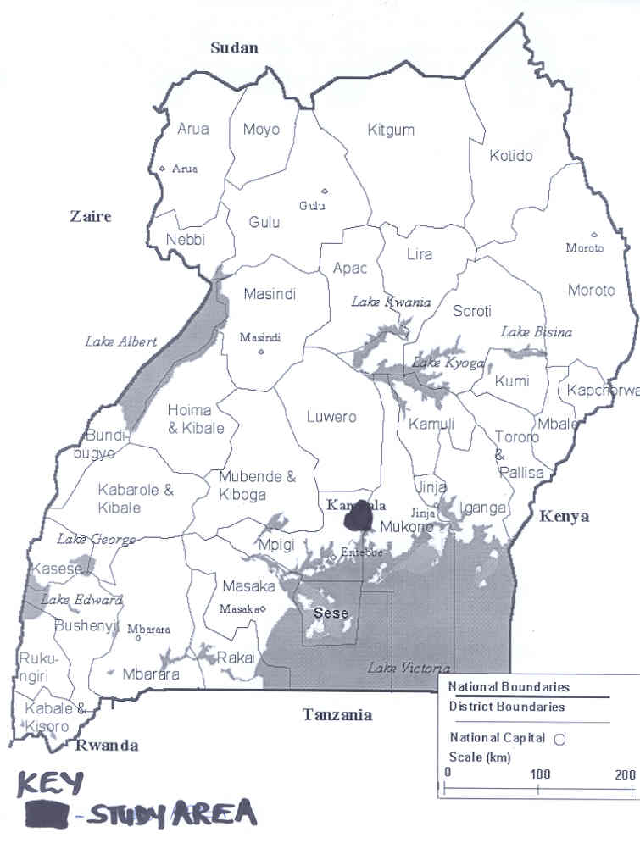

APPENDIX II
Some of the plant species used in treatment of common diseases:

SPECIES LOCAL NAME DISEASE
Piva Cordifolia Enkami Diarrhea
Headache
Vomiting
Malaria
Fever

Sorghum Vulgore Omuwemba Diarrhea
Vomiting

Thunbergia alata Kasamusamu Diarrhea Dysentery
Vomiting
Cough

Albizia Zygia Nnongolongo Diarrhea
Skin rash
Mental disorder
Allergy
Dizziness

