EXPERT SYSTEM-AN INNOVATIVE TOOL FOR MANAGING INDIAN TRADITIONAL MEDICAL KNOWLEDGE

*G.GNANA SEKARI **MANORAMA SRINATH ***G.VELUCHAMY

KEY WORDS
Expert system, artificial intelligence, knowledge base, Indian medical knowledge management

Libraries are now facing a crucial transitional state, which necessitates adopting modern methods of knowledge organization. The advent of Information Technology offers a powerful means of translating intellectual contributions into value-added information products, which satisfies the specific requirements of each end user.

The implications of this phenomenon have reflected a gradual transformation of the physical format of information resources in Libraries. The concept of multimedia Library was introduced when audio-visual materials were added along with the printed media. The next stage has been marked by the digitalization of information and the digital library came into vogue. Digital library does not mean merely converting the information into digital form but it is an asset, which facilitates free flow of exchange of information at global level through Internet. This led to the metamorphosis of library into virtual library.

*****************************************************
*LIBRARIAN, LITERARY RESEARCH AND DOC...DEPT.., C.R.I.S., CHENNAI-106.
**PROFESSOR, HEAD OF DEPT.OF LIB. &INF. SC., UNIVERSITY OF MADRAS, CHENNAI-5.
***PROJECT OFFICER, LITERARY RESEARCH AND DOCUMENTATION DEPT.., C.R.I.S., CHENNAI-106.

This transition of traditional library to electronic library represents a new means of extending and enhancing the value of information and knowledge, which
are scattered in various sources and hidden in different forms and languages. One such valuable knowledge is Siddha Medical System, which is hidden in the form of Tamil poetries. The Siddha medical system is popular in Tamil Nadu to a certain extent but not elsewhere. That is due to the secretive nature of the ‘Siddhas’ who originated the Siddha medical knowledge. Most of the extremely valuable knowledge of Siddha medicine, which is found in the regional language of the Tamils, is now gradually being translated into English and Hindi. It is believed that these medicines arrest the advancement of the some of the killer diseases such as Cancer and Aids, when detected at an early stage.
The systematic organization of this valuable knowledge will prove to be extremely useful for the society. Hence it is decided that an Expert system for Siddha system of Medicine should be designed and it will serve as an effective tool for knowledge management.

Expert System

An Expert System is a knowledge-based computer program containing expert domain knowledge about objects, events, situations and courses of action, which emulates the process of human experts in the particular domain. In other words, expert system is a computer application that performs a task that would otherwise be performed by a human expert. Expert systems are extensively used in the medical field. For example, there are expert systems that can diagnose human illness, and MYCIN is one of the popular expert systems in medical field. Mycin is one of the well-known expert systems and was built in mid 1970 s. This provides consultative advice on diagnosis and the treatment for infectious blood diseases. MYCIN facilitates high level performance of selecting antibiotic therapy for Bacteremia (infectious blood disease) Apart from this, there are expert systems on various aspects such as financial forecasting, schedule routes for delivery vehicles, analysis of structures of chemical compounds and planning of actions sequentially etc. Some expert systems are designed to take the place of human experts while others are designed to aid them.

Different Categories of Expert System

Expert systems can be classified into different categories as stated below:

- Interpretation Systems: This includes analysis of intelligence by way of surveillance, understanding of speech, image analysis etc. Meanings are expressed symbolically and situations described as a result of observation.
- Prediction Systems: These systems infer liable consequences of given situations, such as economic and weather forecasting, demographic prediction, crop estimation and military etc.
- Diagnostic Systems: These systems analyze the organizations’ performance and diagnose the failure even in the medical field.
- Design Systems: These systems develop circuit layout and building design etc.
- Planning Systems: These systems help in automatic planning in project management, routing, communication, military operation etc.
- Instruction Systems: These systems are otherwise called ‘Education and Training systems’ which incorporate diagnosing and debugging of sub-system. These systems diagnose the weakness in the students’ knowledge and identify appropriate remedies and also plan a tutorial interaction to deliver remedial knowledge to the student.
- Model-Based Systems: Here the knowledge is based on human expertise and is represented as rules with which a model is designed as to understand the system and then used to identify the course of the equipments failure.

Tools to design Expert Systems

Expert Systems can be developed by writing programs using certain programming languages, such as, Fortran ,Pascal, C++, Visual Basic and dbase. The languages like Prolog (Programming in Logic) and Lisp (List in Programming) are most significant and are used for designing Artificial Intelligence systems. There are expert systems shells, which are ready made software packages, which facilitate designing of expert system without writing complicated programs. They provide the inference engine and user interface commands. It has the facility to construct the rules in spoken English language and has a built in editor.

Expert System as an effective tool for knowledge organization

Expert system facilitates organization of knowledge in such a manner, which fills up the gap of the absence of an expert in any field. An expert system with hypertext facility will be particularly useful in organizing knowledge in logical manner and facilitates storing of large amount of information with a very effective retrieval mechanism. Hence these two techniques namely expert system and hypertext have been chosen by the researcher to design the expert system of Siddha medicine.
Components of Expert System
Flow Chart No.1

KNOWLEDGE BASE
INFERENCE ENGINE
USER INTERFACE

Knowledge base contains facts and an inference procedure to utilize the knowledge, which is called as inference engine. An ‘user interface’ program has also been incorporated in the expert system, which enables an user to interact with the system.
The ancient Siddha medical system proves to be an alternative effective system for Allopathy. Unfortunately, such wonderful ancient Indian medical system was not popularized due to the secrecy maintained by the ancient Siddhas. The expertise knowledge in this field was not properly organized, and they were written in the form of Tamil poetries, which are not understood by a layman. Recently this medical system, due to its effective remedies, has been gradually gaining popularity even among the western countries.

Hence it is felt by the researcher that this ancient scientific information which are scattered in the form of Tamil Poetries, must be organized in a more logical manner, with English translations so that, it should have a wider use at global level.

The major aim of the study is to create an expert system for Siddha medicine. A knowledge base has been created, which contains three different components. The first component consists of information for twenty five diseases, each comprising of three parts namely ‘General Descriptions’, ‘Signs and Symptoms’ and ‘Treatment’. The second component comprises of the ‘Single drugs’ with which medicines are prepared. The third component consists of medicines that are already ‘patented’ in Siddha medicine. This knowledge base is presented in a textual form since it contains descriptions in two languages (English and Tamil), which is supported with illustrations and pictures.
Expert System is a versatile tool, which can be used as multi-purpose systems such as decision support system, diagnostic system, self-learning tool, and teaching aid etc. Expert systems are quite popular in allopathic field of medicine, which are designed in western countries. So far, no attempt has been made to design an expert system for Siddha medical systems. This study will be an unique one since the knowledge base designed is a bi-lingual one, which includes both Tamil and English.
The methodology adopted to design the expert system is illustrated in this flow chart:
Flow Chart No.2
START
From doctors
Collected Information
From printed sources
Translation
Scanning & Incorporating
Digitalized
Organized
Identified key terms
Pictures of plants
Pathological symptoms
KB for E.S created
Created hyperlink
Problems in the form of queries collected
User interface pro-gram created by using VB&JAVA
Created database
Decision support system
solutions
Target users testing their knowledge
Information retrieval
Feed back

The major aim of the study is to create an expert system for Siddha medicine. A knowledge base has been created, which contains three different components. The first component consists of information for twenty five diseases, each comprising of three parts namely ‘General Descriptions’, ‘Signs and Symptoms’ and ‘Treatment’. The second component comprises of the ‘Single drugs’ with which medicines are prepared. The third component consists of medicines that are already ‘patented’ in Siddha medicine. This knowledge base is presented in a textual form since it contains descriptions in two languages (English and Tamil), which is supported with illustrations and pictures.

User Interface

The hyperlinks provided in the knowledge base facilitate non-sequential browsing. A program is written using MS ACCESS and Visual Basic which facilitates to retrieve relevant information for a specific structured query.

Another program is written using Java Script, which enables the user to type a question with specific key terms to retrieve information from the knowledge base.

Further, the expert system provides a ‘Tutorial Interaction’ for the target users which enables `knowledge testing’ in Siddha medicine.

System Interaction

Apart from the user interface with the system, the system itself puts forth some questions along with some options. The users should select the option and from the interaction, the system will draw conclusions and try to diagnose the disease and provide information on treatment for the particular disease.

Samples from each section will be displayed in the following pages

DISPLAY 1
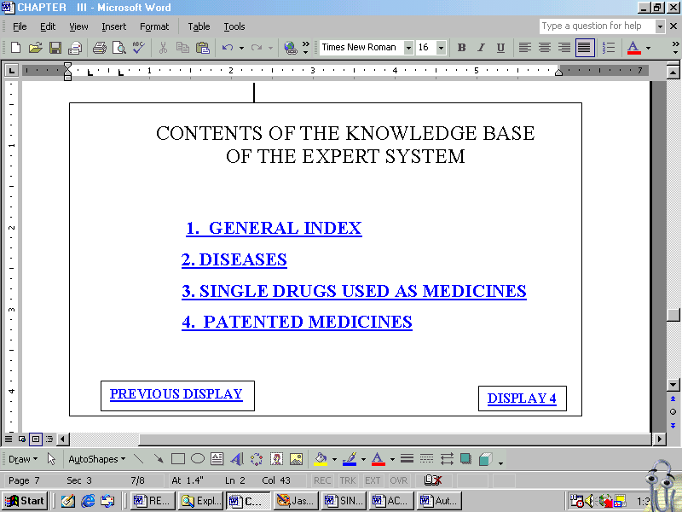

This display serves as a Contents page of the Expert System, which indicates the various parts of the Knowledge base. The above display leads to the four parts of the corresponding Knowledge base created. The term ‘GENERAL INDEX’ leads to the next display, which in turn lists all the indices of Knowledge base.
The term ‘DISEASES’ is hyperlinked with the KB for diseases; the terms ‘SINGLE DRUGS USED AS MEDICINES’ and ‘PATENTED DRUGS’ are hyperlinked with their respective Knowledge base.

DISPLAY 2a
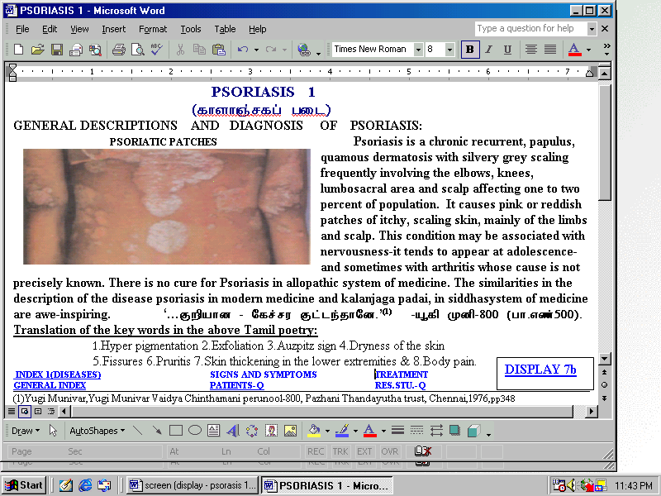
This output is an example for the knowledge base which contains all the features such as information in the form Tamil poetry, citation of the Tamil poetry, incorporation of relevant picture which shows the pathological symptoms.
DISPLAY 2b
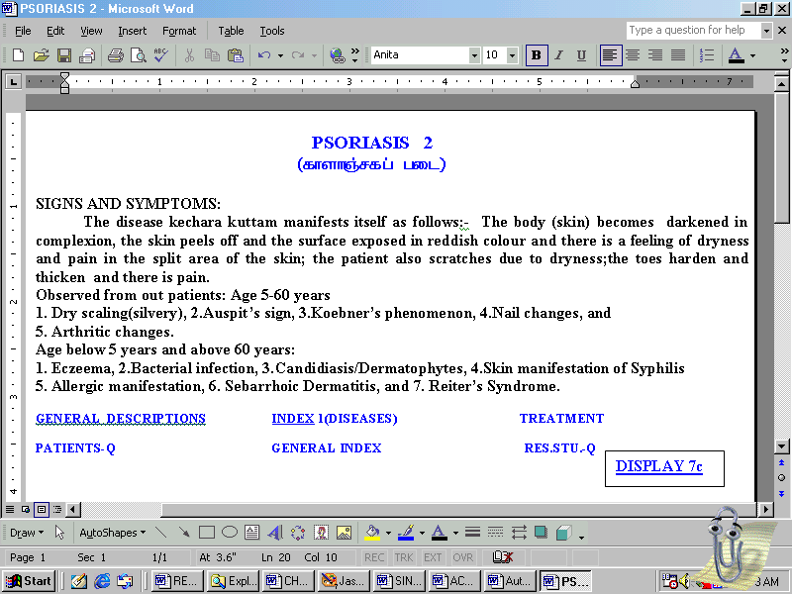

The above display Psoriasis 2 enumerates the signs and symptoms of Psoriasis. The symptoms have been given in detail as according to age groups. All the terms mentioned in the above display serve as hyperlinks. DISPLAY 8a leads to the next disease Sinusitis.
DISPLAY 2c
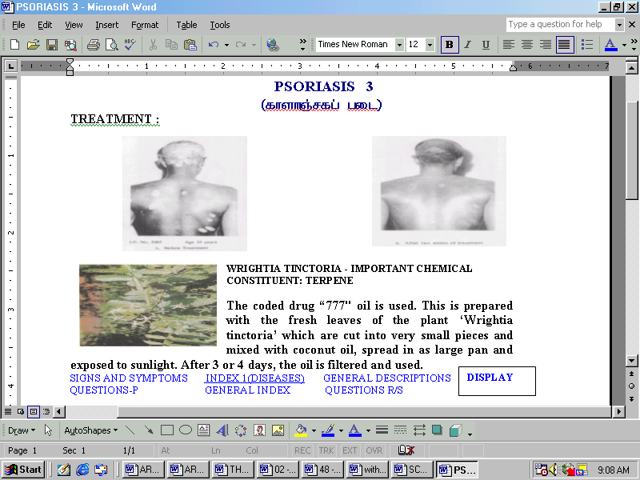

The knowledge base provides treatment for Psoriasis and in the above display, the images of the patient before treatment and after treatment have been shown. Further the plant which is used to prepare the medicine “777 oil” has been shown.

DISPLAY 3

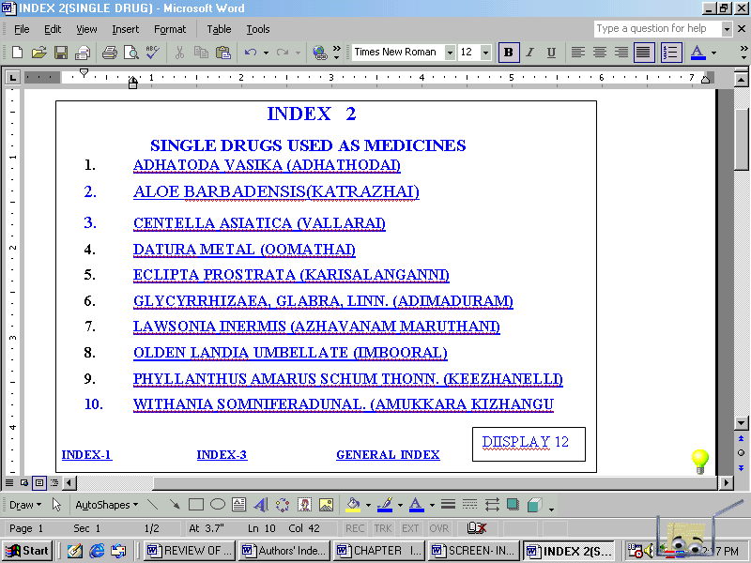

The above Index shows the list of drugs, which are used in the preparation of medicines. The Tamil name of the drug or ingredient is given in the bracket. Each name serves as a hyperlink. Totally 25 single drugs are incorporated in the knowledge base of this expert system whereas, only the samples of the five drugs in this work can be seen in the following displays.

DISPLAY 4
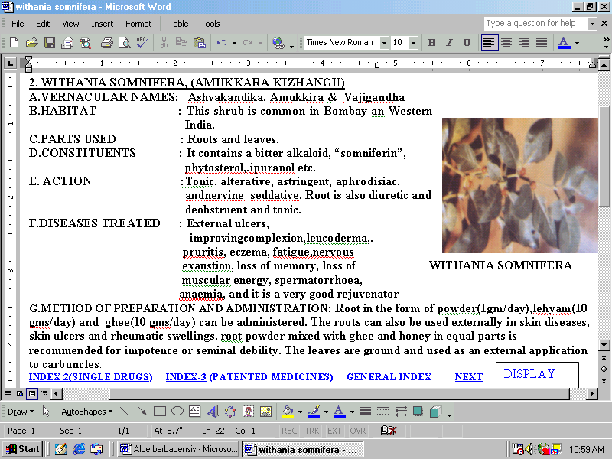

This is the tenth drug listed in the index 2. This display has the vernacular names, and parts as medicines. This drug is also called as “Indian Ginsung” in China, where it is quite popular.
DISPLAY 5

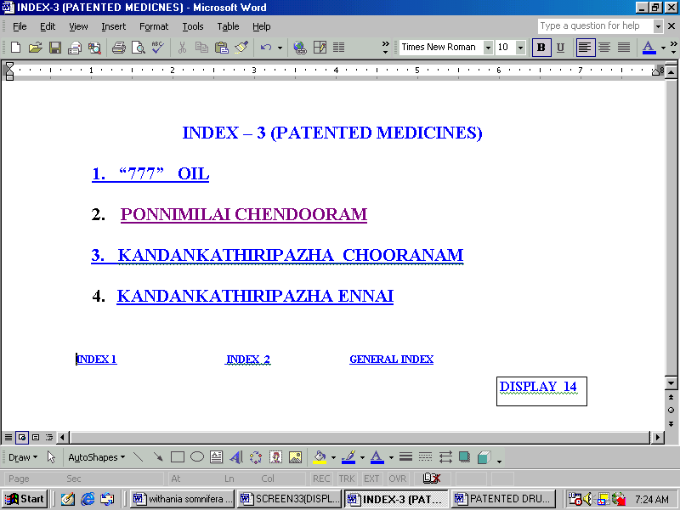

This part of the database provides the information regarding the four drugs which are prepared by Central Research Institute (Siddha), Chennai 106, and obtained patence by the Central Council for Research in Ayurveda and Siddha, New Delhi. The names of the medicines displayed above serve as hyperlinks.

DISPLAY 6
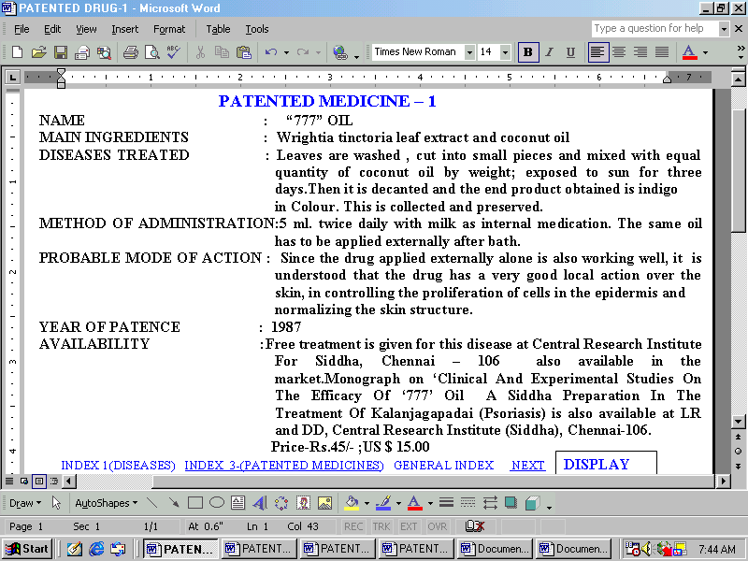

This display exhibits the information about “777” oil which is the unique medicine used for the disease – psoriasis. All the indices have been hyperlinked and the next patented drug will be displayed when the term “NEXT” is activated.

INFORMATION RETRIEVAL FROM EXPERT SYSTEM

The effectiveness and usefulness of the expert system depends on the user interface program.

Hence this expert system has two significant features, namely user interaction and system interaction.

User interaction allows the user to retrieve information by formulating queries and browsing the knowledge base. The system interaction, facilitates interrogation by the system itself, and on the basis of the answers provided by the user, it diagnosis the disease. Further it also provides treatment for the disease.
The Expert System designed facilitates information retrieval in five different methods as indicated below:-
User interface
- Sequential browsing of knowledge base,
- Non-Sequential browsing by activating the hyperlinks,
- Information retrieval for general queries raised frequently by the under graduate students, research scholars and patients,
- Information retrieval for specific queries for each diseases,
- System Interaction :
System interrogates and draws conclusions.
- Tutorial Interaction :
Lastly, the users of this Expert System can test their own knowledge by selecting the options displayed by the system. Sample outputs of the information retrieval are provided in the following pages.

SEQUENTIAL BROWSING
DISPLAY 7
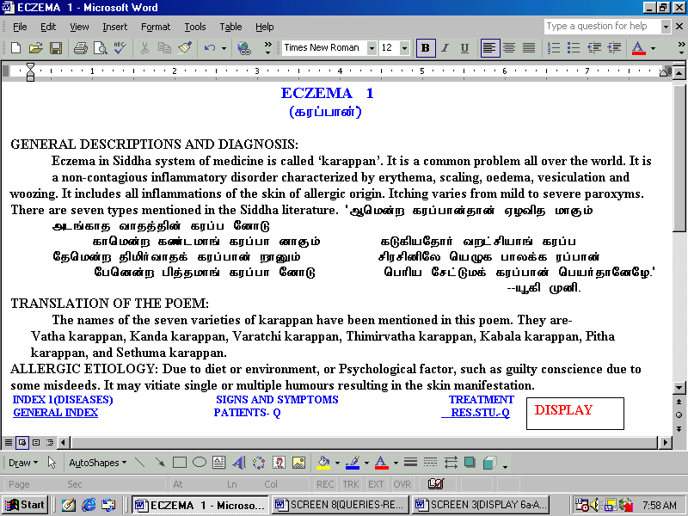

This is the information regarding the eleventh disease included in the knowledge base. Display 22 to 24 shows general descriptions, signs and symptoms and treatment aspects of the disease – Eczema. The links created will lead to the respective parts of the knowledge base. Links are also provided for the user interface program. PATIENTS-Q leads to the general queries regarding Eczema, raised by the patients. Similarly, RES.STU.-Q link leads to the queries raised by the research scholars and post-graduate students. When the term ‘Display 5b’ is activated it will lead to the next display in a sequential manner.
DISPLAY 8
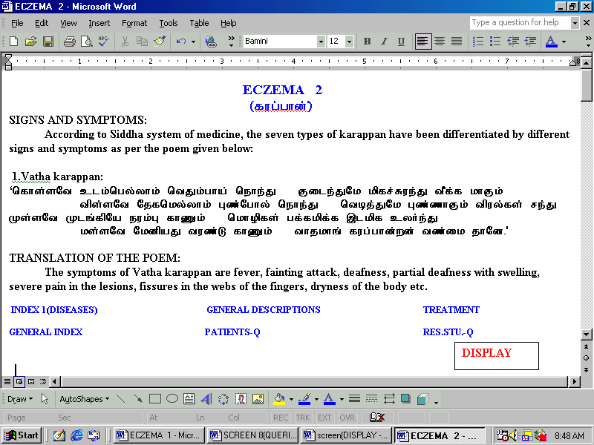

This is the Second Sample for sequential browsing. When the display is clicked it will lead to the next display. This display proves the bilingual nature of the knowledge base.
DISPLAY 9
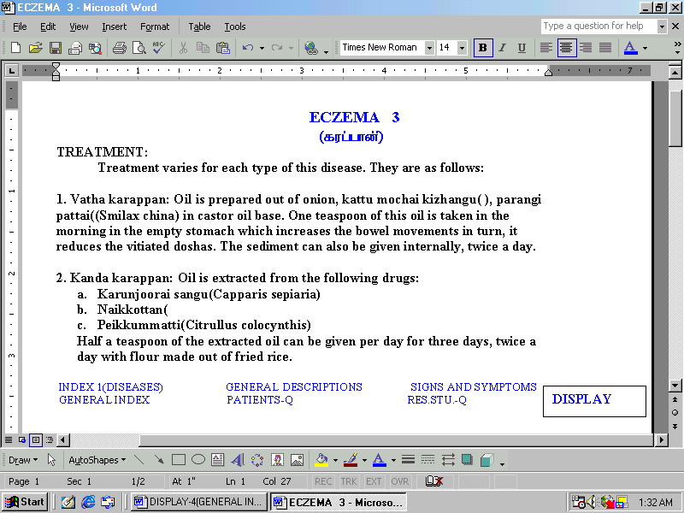
The treatment for Karapan is given here which is an another example for sequential type of knowledge base.

NON - SEQUENTIAL BROWSING
DISPLAY 10
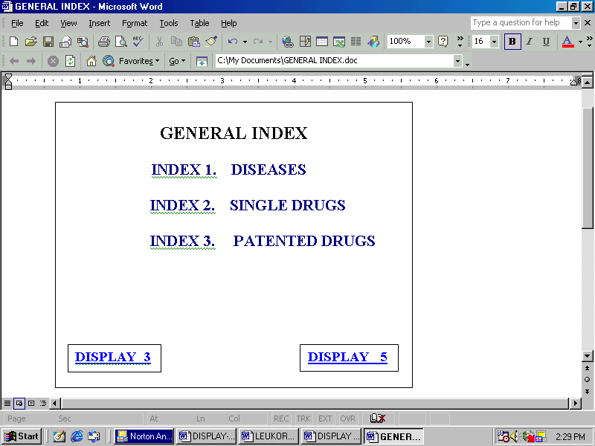
The term ‘Index 1’ will lead to the alphabetical index of the disease included in the knowledge base. Similarly, the terms ‘Index 2’ and ‘Index 3’ will display the alphabetical list of drugs prepared by single ingredients and patented drugs respectively. This is the sample display for non-sequential browsing of knowledge base. When one of these index is activated it will lead to the respective index.
DISPLAY 11
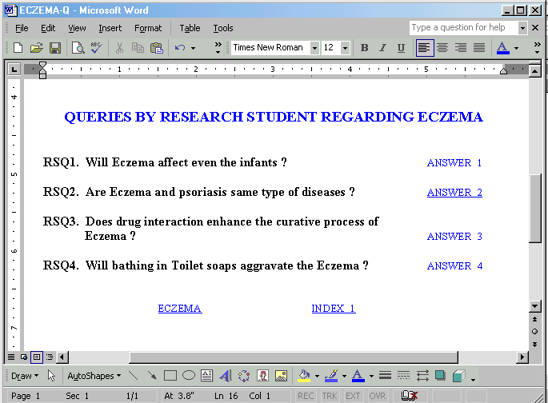

This is the sample display for the queries raised by the research students regarding the disease ‘Eczema’. It shows four queries about Eczema and the terms “Answers” will lead to the respective information.
DISPLAY 12
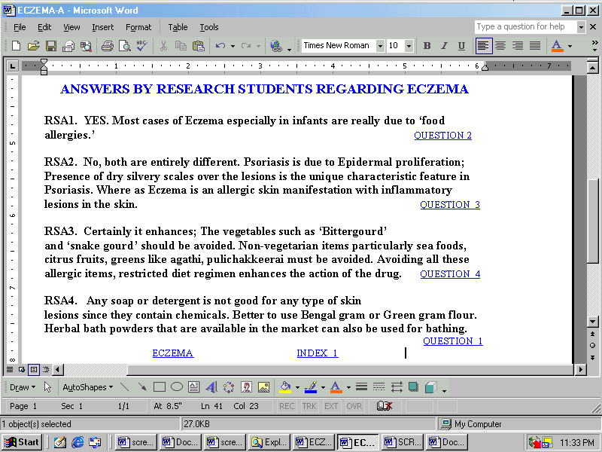

The answer for the four queries displayed in the previous page has been shown here. Again from this display the user can go back to the questions.

DISPLAY 13
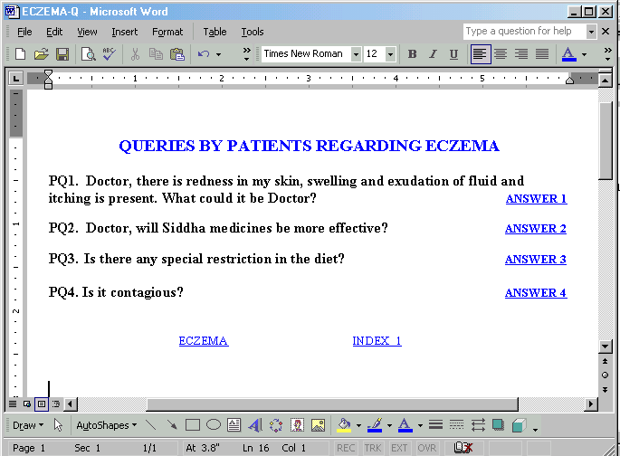

This is the sample display for the queries raised by the patients regarding the disease ‘Eczema’. The word ‘Answer 1’ is hyperlinked with the first answer in the next display. Hence, when it is activated, the cursor blinks at ‘RA1’ which is displayed on the screen.
DISPLAY 14
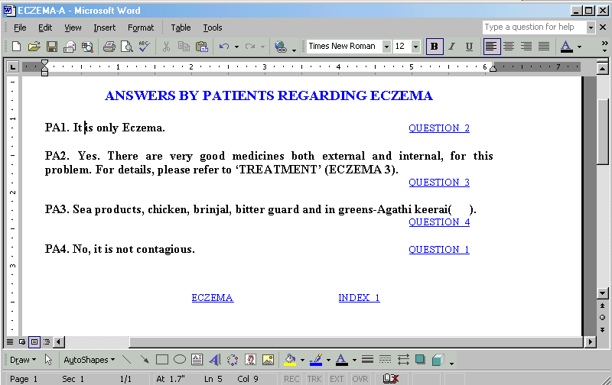
This is the sample display for the answers retrieved for the query raised by the patients regarding the disease ‘Eczema’. The term ‘Question 2’ is linked with the second query, in the previous display. Hence, when the term ‘Question 2’ is activated, the cursor blinks at the ‘PQ2’ which is displayed on the screen.

INFORMATION RETRIEVAL FOR SPECIFIC QUERIES
USER INTERFACE 1

DISPLAY 15
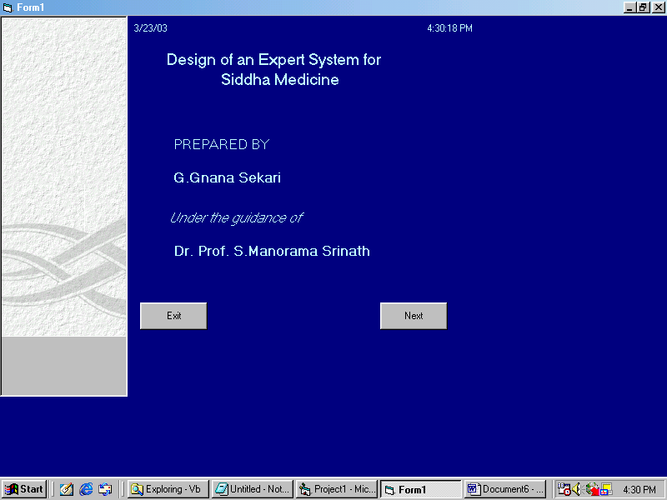
This is the opening page of expert system which facilitates retrieval of information by formulating structured queries. This structured queries output has been displayed in the following pages. Only for five diseases, which have been included in the chapter four.This part of the expert system is designed by using Visual Basic and Access.
DISPLAY 16
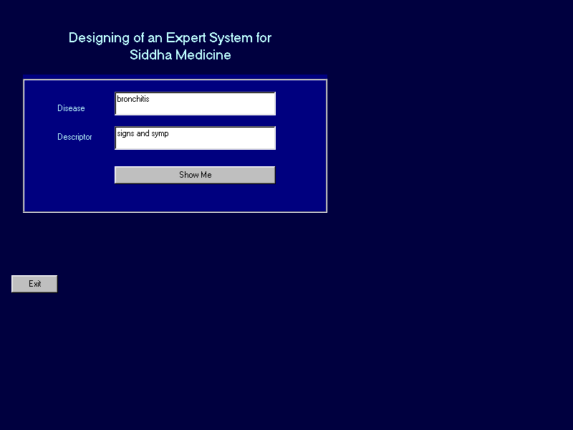

The above display shows the query format. In the first text box the name of the disease will be typed and the second text box “treatment” is typed. When the button “show me” is clicked the relevant information will be retrieved.
DISPLAY 17
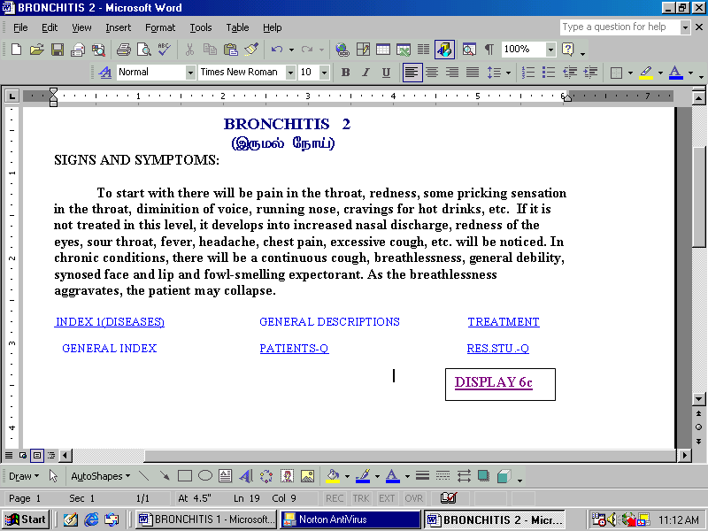
This is the output for the query typed in the previous display.

USER INTERFACE 2
DISPLAY 18
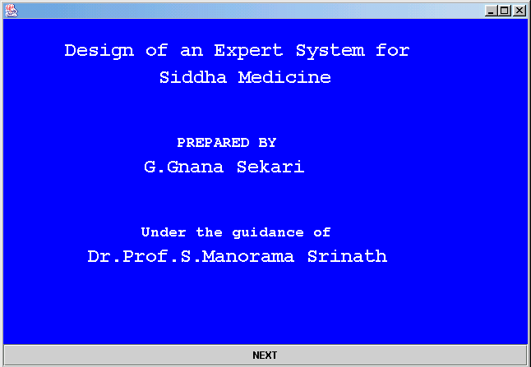

This portion of the expert system facilitates information retrieval by the user by typing his query and the system will provide the answers. The following pages provide information for five specific questions.This part of the expert system is designed by writing programme using Java Script.

DISPLAY 19
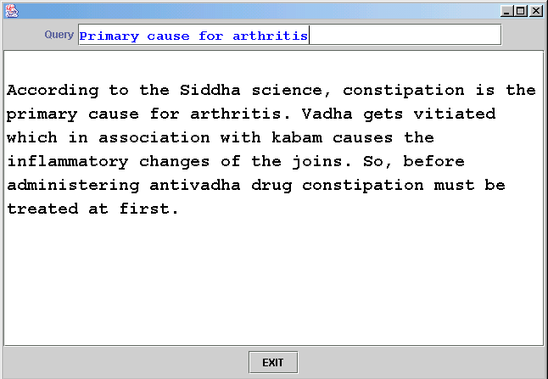
The query primary case for Arthritis has been typed and the system retrieves answer for the same from the knowledge base, which has been displayed above.

SYSTEM INTERACTION
DISPLAY 20

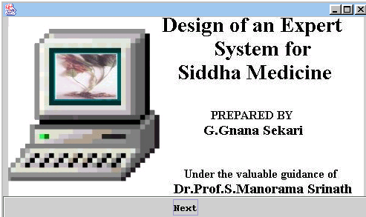

This part of the expert system facilitates system interaction. This part is designed by writing program in Java which displays windows for interactions of the patients.
That is the system will ask the user a series of questions and on the basis of the answers provided by the user the system will draw a conclusion and diagnose the disease.
SYSTEM INTERACTION

The System Interaction program has been designed in this expert system apart from the two interface programs. In this program, the system itself puts forth some questions along with some options. The user can select any one of the options and the system will respond. From the interaction with the user, the system will draw conclusions and try to diagnose the disease. Finally it also provides the information on treatment for the particular disease.

The system interaction program has been designed using Java. The opening page facilitates the user to go to the first question, when the user clicks the “NEXT” button.

The window offers two options “Yes” and “No”. Along with these two option buttons three more buttons have also been provided.

The “Continue” button enables the user to go to the first question. Another button “Back” is provided to go back to the previous question, interrogated by the system. The third button “Exit” facilitates the user to come out of the system interaction program, if he/she desires.

The series of questions interrogated by the system have been detailed in the Flow Chart – 8 in the following page.

The System interaction with user is shown in the Diagram below
Flow Chart - 8
Do you have head ache and running nose?
No
Yes
No
Do you have sneezing and nasal block ?
You don’t have any problem in the lu

ng;
you are alright;
Yes
Do you have tightness of the Chest (Spasm) ?
You have common cold; you must take Thalisathy Chooranam or Adathodai Chooranam 500 mg thrice a day, with honey for 3 days.
Yes
No
Do you hear any wheezing sound, when you breath?
Yes
No
You may have Bronchitis please see the treatment part of the Bronchitis (Bronchitis 3)
You may have Sinusitis. Please see the treatment part of Sinusitis. (Sinusitis 3)
Do you feel hard to breath ?
Yes
No
DISPLAY 21
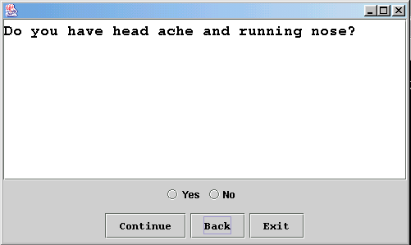

The system will prompt with a question as shown above. Two options are given below. If the user selects “Yes” it will lead to the next question which is shown in display (51). If the user selects option “No” it will lead to the next display no 57.
DISPLAY 22
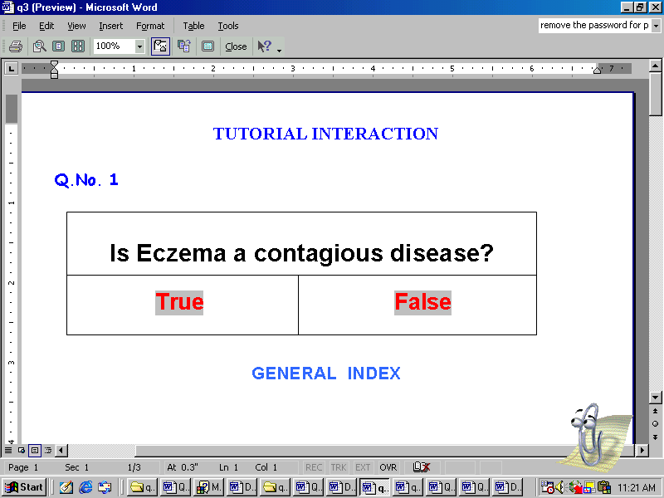

If the user select the option “True” it will lead to the next display.
DISPLAY 23
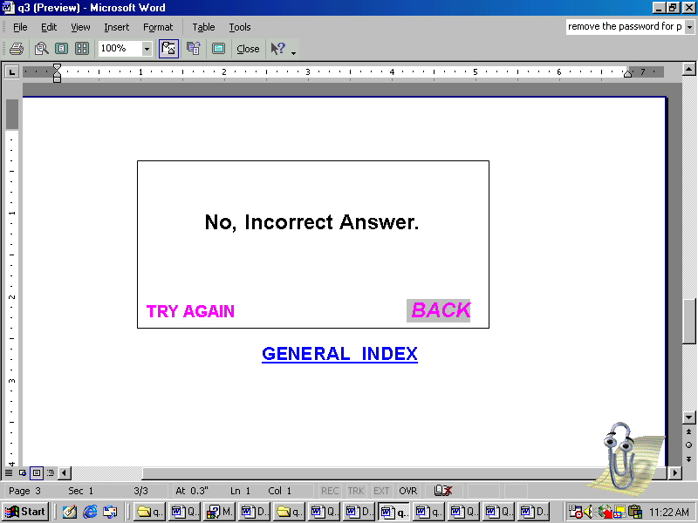

This is the second display for the first query. When the user selects the “True” option, it leads to the display. Since the option was wrong, it says “No, incorrect answer”. But it facilitates the user to go back and find the correct answer by activating the term “Back”.

DISPLAY 24
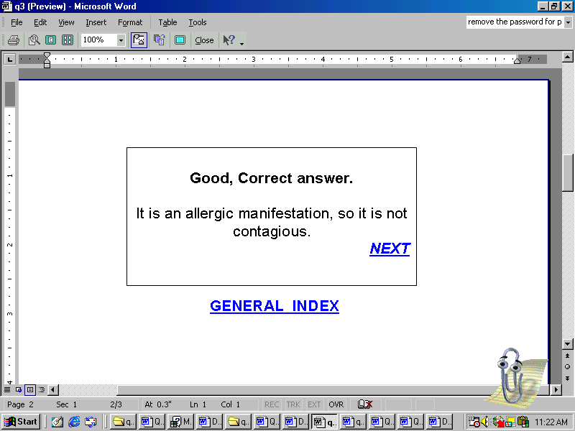

If the user selects the option “False” for the first question “is Eczema a contagious disease?” the system will not only indicate it is correct answer it also provides the logic behind the answer.

This expert system has proved to be a value – added and decision – aid information product in research library, which is the ultimate motive of designing this system. Such value-added, tailor made products will definitely attract more readers and motivate them to use the resources to the maximum extent.

Designing of such expert systems will play a significant role in developing digital libraries. Such efforts will definitely enhance the reputation of the Library Professionals and prove that they are no way behind the technological advances in the field of Library & Information Science.

This paper has highlighted that Expert System is an innovative tool for managing knowledge in any domain.

*******************************
REFERENCES:
Chadvick, M. et al, (1990) Exper Systems for Personal Computers, Gal Gotia Publications Pvt.Ltd., New Delhi.
Beerel, A.C, (1987) Expert Systems : Strategic implications and applications, Chichester, Ellis Horwood Limited, West Sussex.
Gnana Sekari, G. et al, Expert System : A Tool for Managing Digital Asset. Proceedings of the National Conference on Recent Advances in Information Technology (READIT 2001), I.I.T. Chennai. Pp.8-10.
Waterman, D.A, (1984) A guide to Expert Systems, Reading, Addison-Wesly, Massachusetts.
Wiig, Karl, Expert systems : (1990) A manages’s guide, Oxford & IBH Publishing Co. Pvt. Ltd., New Delhi
***************************************************************

