USE OF KNOWLEDGE MAPS REPRESENTING TRADITIONAL MEDICAL INFORMATION
Manorama Srinath * G.Gnanasekari **
Key words: Knowledge map, knowledge assets, knowledge management, Tacit knowledge, Explicit knowledge, Knowledge eco system.
Knowledge management is systematic management of vital knowledge of any organization and its associated processes of creation, organizational, diffusion, use, and exploitation. Knowledge management facilitates the achievement of organizational goals effectively. It consists of the systematic processes, such as create, capture, share and leverage the knowledge that is needed for an organization to succeed.
Knowledge management
This concept has been discussed in different ways by different people. The stages of KM have been viewed in different angles. Km consists of the following processes:
*Identification of knowledge sources such individuals, groups, and organizations as resources with expertise or experience in specific areas of health (or any other domain) who are willing to share their tacit knowledge.
*Storage of knowledge in the form of knowledge base which facilitates retrieval, updating, monitoring, and
archiving.
*Packaging of knowledge, with different content details for specific target groups of policymakers, practitioners, researchers; and decision makers.
*Coordination of intellectual resources such as individuals, groups, and organizations etc.
*Knowledge use refers to the manner by which it is used to create new knowledge
*Distribution of knowledge through different modalities such as newsletters, bulletins, and Web-based resources to targeted audiences;

-------------------------------------------------------------------------------------------------------------------------
*Professor, Department of Information Science, University of Madras, Chennai, 60 00 05 India
**Librarian, LR&DD, Central Research Institute (Siddha), Arumbakkam, Chennai 600106, India

*Sharing of knowledge through interpersonal communications such as conferences, videoconferences discussions and workshops etc
*Application of the knowledge and adaptation of the knowledge to suit local environment such as values, culture and procedures.
When new knowledge is developed which can be know-how or a new technique, it should be captured, stored and shared for the development of organizational learning. Knowledge management involves enhancing organizational knowledge through sound practices of management of knowledge assets. The employees who have acquired knowledge about their organization are carriers of knowledge capital. They carry the company's knowledge capital which is the most important asset of an organization. The knowledge assets are not presented in the organization’s financial assets. Knowledge assets play a significant role in managing any organization effectively
Knowledge assets
Knowledge assets originate in the creative minds of employees within the organization. Knowledge is embedded in the individual’s brain which becomes knowledge assets of an organization when it is encoded in the form organizational process, documents, products, services, facilities, and systems. The value of total knowledge capital can be assessed in tangible manner by summing up the value of patents, software, products and trained people Knowledge is the driver of current global economy.
Types of knowledge
Knowledge is inherent in ideas, judgments, talents, experience, perspectives, and concepts. There are different knowledge classification schemes and taxonomies.
Tacit knowledge is hard to express in an explicit manner because it is generally expressed in action-based skills which is needed to act and react in an environment. Tacit knowledge is not structured; intangible cannot be recoded and represents experience ideas insides values and judgment of people.
Explicit knowledge referred as procedural knowledge which can be written or documented. Explicit knowledge is semi- structured and represents tangible or recorded knowledge. They can be expressed formally and communicated easily.
Organizational knowledge can be defined as the collective knowledge assets and the processes that could be employed to take effective action to achieve the organizational goals. It is important to identify and recognize the knowledge, which has an impact on the overall performance of an organization.
Managing the knowledge of an organization is highly complex process and value based. It is essential that the knowledge synchronizes with the organization’s mission, strategy and development of organizational culture. Successful management of organizational knowledge can dramatically improve the ability to compete with other organizations and to develop sustainability.
Organizational knowledge sources
An organization's competitive spirit and ongoing sustainability primarily depend on their ability to continuously redefine to their goals. This can be achieved by extracting knowledge from the various data and information pools intrinsic as well as extrinsic to an organization. Knowledge can be anywhere, and understanding knowledge can be difficult until the use of it becomes clear. Knowledge sources can be classified under three major headings
A knowledge Eco system
A knowledge eco system consists of people in communities co-located in the same place (People network), who continuously create ideas and (knowledge network) and develop tools and practices for creating, integrating, sharing, and using knowledge (technology network)

Knowledge map

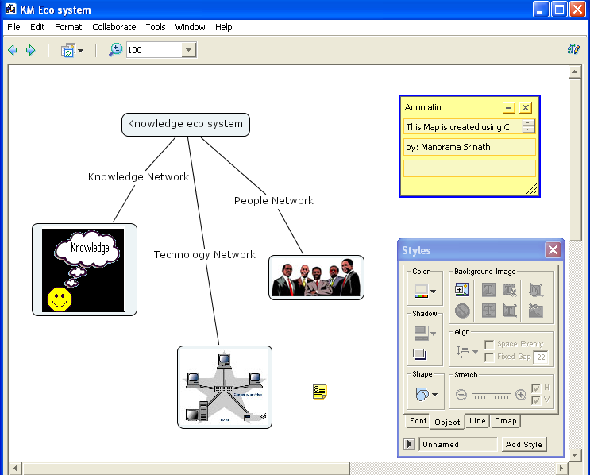

Knowledge eco system of traditional medical information.
Pople network.
The people network of the ancient medical information in India consists of saints (Siddhars), village medical practitioners and modern medical practitioners.
Knowledge network is traced back to ancient times where the knowledge of Siddha and Ayurvedic medical systems were originated by the saints, which are now popularized by the present medical practitioners.
Technology network is the result of modern KM tools emerged from the advanced Information technology in this modern Information era. Knowledge mapping technique is one of the emerging topics.
Organizational knowledge mapping techniques
A knowledge map is a navigational aid to explicit (codified) information and tacit knowledge. It represents the sources, flows, constraints and sinks. An organizational knowledge map is also called as knowledge models. There are various ways of representing knowledge models. They are recently referred as concept maps. Concept maps are effective visualization tools for representing knowledge of any organization. Joseph D. Novak popularized the phrase 'concept map' and his work” Learning, Creating, and Using Knowledge”, (1998) has been widely recognized
Knowledge mapping represents the on going quest within an organization. Knowledge maps help to represent explicit and tacit knowledge, which highlights islands of expertise knowledge. Information scientists take pride in calling themselves as Knowledge managers; hence it is essential to understand this complex domain called knowledge management and knowledge mapping technique. Knowledge map presented in this article, comprises of symbols (images and shapes) called nodes, lines that connect the nodes (links), and propositions (words on the links) that make the connection between nodes meaningful.

Knowledge mapping
In this article the knowledge mapping technique has been used to explain how knowledge maps can be utilized to illustrate knowledge assets of medical information. Since India is rich in traditional medical systems such as Ayurvedic and Siddha, which are based on herbal medicines and not very popular in western countries, it was felt that the same could be used to represent knowledge mapping technique.

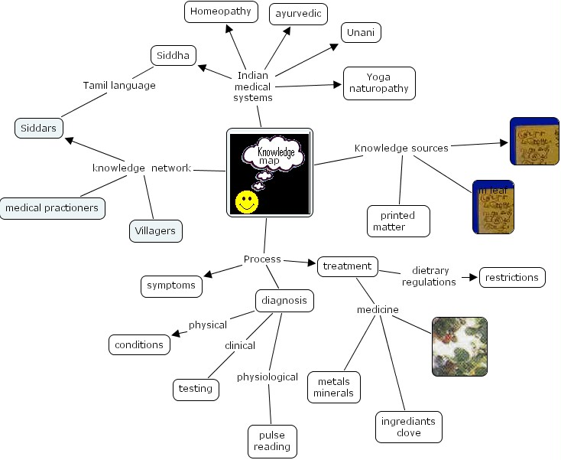
The concept of KM is yet to develop as a full fledged topic and it is still in a nascent stage in field of medical field. Many of related articles are on theoretical basis. This article is almost a first attempt in representing the knowledge map of Indian traditional medicine

References:
Toward a Conceptual Knowledge Management Framework in Health by Francis Lau, Perspectives in Health Information Management 2004, 1:8 (September 20, 2004)
Warier, Sudhir.E. Knowledge management, Vikas publishing House LTD, New Delhi, 2003

