Services for Handheld Computer: First steps towards the Mobile Library
Oliver Obst

Branch Library of Medicine
University and Regional Library

Westfaelic Wilhelms University

Münster, Germany

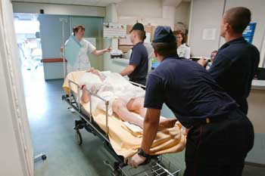

1. Still stationary
Today, most libraries are hybrids in the continuum between „traditional“ (paper-oriented) and „digital“ (online-oriented) libraries. Both are stationary, because the user has to look up a physical place, let it be the library itself or the library‘s home page on the desktop pc. This is problematic in settings, where questions arise at every time and place. This is especially the case in hospitals: Clinicians need answers at the point of care and mostly they have no time for a break to locate the information in need at the desktop or the library. The consultation of library resources is too time consuming and most questions are too urgent: Obviously, patient care and stationary libraries do not fit together very well. There are initiatives to close this gap, such as the Clinical Medical Librarian or UpToDate, but they are only affordable for a few libraries.

Because questions will not become stationary, answers have to become mobile
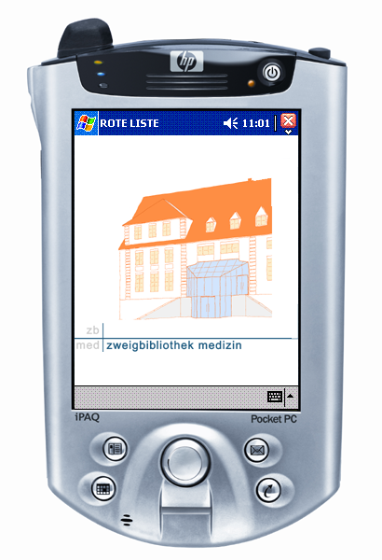
2. Go for mobile
How to overcome the separation of questions and answers in time and space? How to deliver information in need at the point of care? Because questions will not become stationary, information has to become mobile: The „Mobile Library“ is the concept of a library, which will make its services not only available at a physical place, but to everyone at every place at every device. As such, the library is mobile, e.g. is always at the point of need. The mobile library offers offline and online (WiFi) applications for tablet pcs, smart phones, handheld computers, and whatever device which may probably emerge.
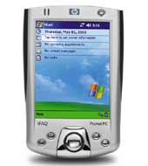
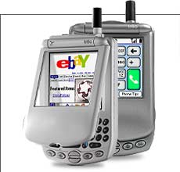
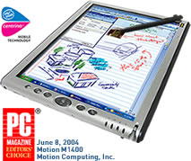
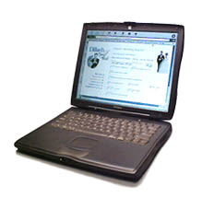
Services for any device which may emerge

Several studies concluded: If mobilisation of information sources increases, the quality of patient care increases too. Seemingly, the hospital is quite a good work place for mobile information and fortunately many physicians already are using mobile devices such as handheld computers.

3. Instant implementation
In 2003 the Medical Library of the University of Münster successfully implemented a rental service for handheld computers. Based on the idea “We lend out books on paper, why not lend out books on handheld computer?”, the library lent out nine Pocket PCs (iPAQ 1930, 3870, 4150) and Palms (Tungsten E) for faculty for 4 weeks each. More than 20 resources were offered on these devices, e.g.:
- Clinical Evidence (BMJ PG)
- Differential Diagnosis Internal Medicine (Mediheld)
- Dorland‘s Pocket Medical Dictionary
- Drug Interaction Facts (Ovid@Hand)
- Harrison on Hand (Mc Graw-Hill)
- ICD-10 (Disease Coding Scheme)
- Laboratory & Clinical Medicine (Mediheld)
- Lexi-Comp Drug Information (UpToDate)
- Medline (Ovid@Hand, Unbound)
- OPS301 (Disease Coding Scheme / Surgery)
- Oxford Handbook of Clinical Medicine
- Red List (German Pharmacopeia)
- Stedman‘s Medical Dictionary
- Taber’s Cyclopedic Medical Dictionary (Unbound)
- Textbook of Internal Medicine (Herold)
- UpToDate (WiFi and SD-Card)

And if you don‘t come to the Library, the Library is coming to you ...

4. Satisfaction guaranteed
Up to hundred researchers and clinicians are using the devices as well as the applications, which the library licensed campus-wide. The overall usage as well as the satisfaction rate were estimated. Every fifth clinician already owned a handheld computer, with half Pocket PC and half Palm devotees. Only 50% of them had some kind of medical application installed. Most requested and most used resources were the drug pharmacopoeias. The main German one, the „Red List“, was definitely number 1, closely followed by Medline, laboratory parameters, and drug interactions. The clinicians were very satisfied with this service: On a scale from 1-5 (1 = very satisfied, 5 = very unsatisfied) they rate the service a favourable 1,43.

Since the beginning of 2005, the library is offering a bundle of handheld applications, which were licensed for the campus. This was heavily requested from the users, as you can see in the box above. More than anything else our clients love these bundles, because they could install and use them for free on their own handheld.

Which PDA applications do our customers need? The diagram below shows that Drug information, Medline, and Laboratory Medicine are the most desired resources.

This prestigious project came to the right time and to the right audience: The users praised the library for its engagement for mobile information sources. Overall, offering services for handhelds raised the reputation of the library.

Lessons learned
1. Lending of handheld computers is of limited use. Customers must have their own device because the two most important tools were calendars and contacts.
2. Instead, the purchase of licenses for the campus proved to be very successful. Even if it‘s a very time consuming process (because except of Ovid no vendor had business models for campus licenses), this is the most promising way to attract customers to this service. The library‘s strategy is to offer an area for testing these devices and applications.

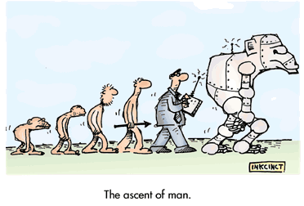
The Evolution of the Library
What comes after the Mobile Library? What is the next shape the library will take in the future? The 4th stage of the evolutionary process is the „Ubiquitous Library”. This Library will be mainly invisible, e.g. fully integrated into the continuous flow of information within and around us. This flow may well be called the information biosphere. It is generated by the future information technology, which will be distributed in the human environment, instead of bundled on the desktop. In the information biosphere, there is no need for any additional device, that must be switched on - this sphere is ubiquitous and always present. What is the backbone and what is the content of the information biosphere?

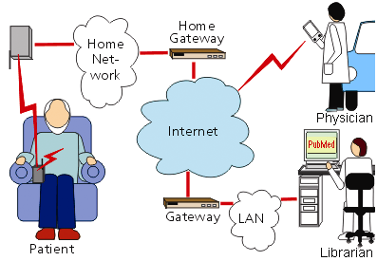

The backbone of the biosphere are the „Body Area Networks“ (BAN), which provide the physical infrastructure for interconnecting the human being with the surrounding information sphere. BAN consist off and connect tools such as speech-driven phones, virtual monitors, intelligent plaster, and other diagnostic elements.

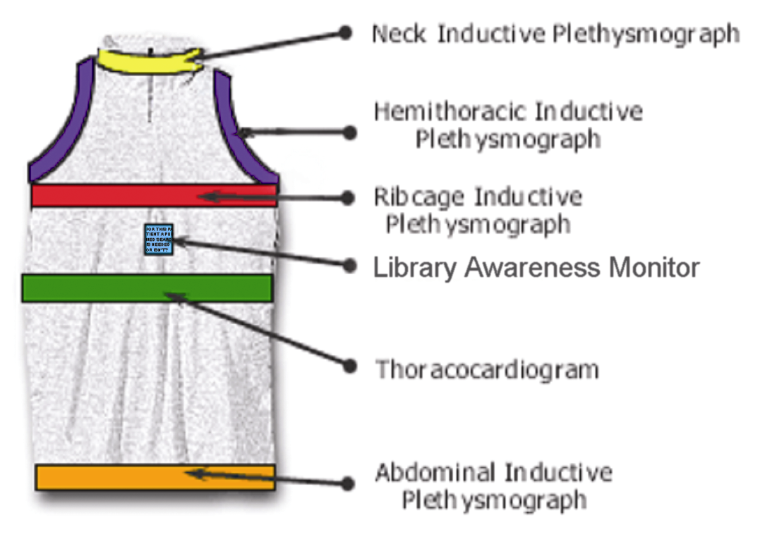

The information content will be structured and delivered by librarians - as always. They may be called information professionals, IT-people or informationists, in fact they are the priests of the coming info sphere. This sphere will bring the ultimate solution for the demands of today: Just as people can communicate where and when they want nowadays, they will expect this freedom of time & place from information sources too. They will not go for an answer to some remote place nor wait for it - they want it here and now. Access is immediate and ubiquitous or it is not - and libraries should deliver it in that way.

